# Introduction and Background

## Purpose

Every four years, the Wasatch Front’s two metropolitan planning organizations (MPOs), Wasatch Front Regional Council (WFRC) and Mountainland Association of Governments (MAG), collaborate to update a set of annual traffic analysis zone and small area population and employment projections for the Salt Lake City-West Valley City (WFRC), Ogden-Layton (WFRC), and Provo-Orem (MAG) urbanized areas.

These projections are primarily developed for the purpose of informing long-range transportation infrastructure and services planning done as part of the four year Regional Transportation Plan (RTP) update cycle, as well as Utah’s Unified Transportation Plan, 2019-2050. Accordingly, the foundation for the most recent projections is largely data describing existing conditions for a 2015 base year, the first year of the latest RTP process. The projections are included in the official travel model, which are publicly released at the conclusion of the RTP process.

## Introduction to REMM

WFRC and MAG have developed a spatial statistical model using the UrbanSim modeling platform to assist in producing these annual projections. This model is called the Real Estate Market Model, or REMM for short. REMM is used for the developable urban portions of Weber, Davis, Salt Lake, and Utah counties.

While REMM models future development at the parcel level, the predicted demographic and employment count and distribution produced by REMM for each future year is used to inform WFRC and MAG’s forecasts at theTraffic Analysis Zone (TAZ) level. The combined Wasatch Front model space has over 2,800 TAZs, whose boundaries are set along roads, streams, and other physical features. WF TAZ geographic units average about 600 acres (0.94 square miles). TAZ sizes vary, with some TAZs in the densest areas representing only a single city block (25 acres).

WFRC and MAG make generalized household and employment forecasts, sourced in large part from REMM, available for [download and use as web services](http://data.wfrc.org/search?q=projections) at the TAZ level and at a ‘City Area’ aggregated level. While REMM produces more detailed results, the following variables illustrate a few of REMM’s more valuable outputs:

* *Demographics*
  + *Household Population Count (excludes persons living in group quarters)*
  + *Household Count (excludes group quarters)*
* *Employment*
  + *Typical Job Count* (includes job types that exhibit typical commuting and other travel/vehicle use patterns)
    - *Retail Job Count* (retail, food service, hotels, etc)
    - *Office Job Count* (office, health care, government, education, etc)
    - *Industrial Job Count* (manufacturing, wholesale, transport, etc)

REMM relies on an extensive set of GIS and other data inputs to simulate future development activity across the greater urbanized region. Key inputs to REMM include:

* Demographic data from the decennial census;
* County-level population and employment projections -- used as REMM control totals -- are produced by the University of Utah’s Kem C. Gardner Policy Institute (GPI) funded by the Utah State Legislature;
* Current employment locational patterns derived from the Utah Department of Workforce Services;
* Land use visioning exercises and feedback, especially in regard to planned urban and local center development, with city and county elected officials and staff;
* Current land use and valuation GIS-based parcel data stewarded by County Assessors;
* Traffic patterns and transit service from the regional Travel Demand Model that together form the landscape of regional accessibility to workplaces and other destinations; and
* Calibration of model variables to balance the fit of current conditions and dynamics at the county and regional level.

As the primary purpose for the development of REMM is producing population and employment projections and to model future travel in the region, REMM-based projections do not include population or households that reside in group quarters (prisons, senior centers, dormitories, etc), as residents of these facilities typically have a very low impact on regional travel. USTM-based projections also exclude group quarters populations. Group quarters population estimates are available at the county-level from GPI and at various sub-county geographies from the Census Bureau.

## History

In the late 1990’s Wasatch Front Regional Council (WFRC), in partnership with Mountainland Association of Governments (MAG), began working on the development of a land use model -- later to be named the Wasatch Front Real Estate Market Model (REMM) -- using the UrbanSim software platform.

The earlier version of the land use model for the WFRC/MAG metropolitan planning organization (MPO) areas was used to support socio-economic forecasts for two regional transportation plans and the Wasatch Choice for 2040. In about 2010, the UrbanSim platform was replaced with OPUS (Open Platform for Urban Simulation).

The transition to an open source code-based platform offered a decision point at which time WFRC and MAG reexamined the land use modeling approach for the region. The options were: 1) abandon REMM and go back to a spreadsheet or GIS-based tool (not integrated with the travel demand model); 2) upgrade to the UrbanSim2 platform; or 3) switch to a different land use forecasting platform. After spending nine months of extensive research, including interviewing peer agencies, WFRC made the decision to upgrade to the UrbanSim2 platform. UrbanSim2 is more robust, flexible, and user-friendly than the previous version. In addition, the software is free, has an open code base, and has a relatively large user group with which to collaborate.

During the four year 2019 Regional Transportation Plan (RTP) cycle, WFRC and MAG staff, with support from the Utah Department of Transportation (UDOT) and the Utah Transit Authority (UTA), have worked to collect and clean required input data, refine REMM’s model structure, and select and implement, within the model, the factors which best predict development activity in our region through updating specification and estimation of model variables.

The socioeconomic forecasts that REMM (v1.0) produces directly inform the Wasatch Front Travel Demand Model (WFTDM v8.3), and vice versa. REMM forecasts and the WFTDM toolset will be officially released with the 2019-2050 RTP adopted by the WFRC and MAG governing boards.

# Overview of REMM

## Geographic Coverage

Currently, the modeled area within REMM has included all of the developable area of Utah, Salt Lake, Davis and Weber counties, with the exception of the canyons and mountains to the east of the major urbanized areas. The population in the excluded areas is small and is not part of the urbanized area defined by the US Census Bureau, and tends to be separated from the urban area by distance and mountainous terrain. For the same reasons, it is unlikely that these areas will be incorporated into the modeled area in the near future.

Recently, southern Box Elder County was included into the WFRC metropolitan planning area. This new area generally includes the cities of Willard, Perry, and Brigham City. Currently this area in Box Elder County is not included within REMM’s model coverage area. However, there are plans to expand the model’s coverage to include this area in the near future. In the meantime, socio-economic projections are created using a manual forecasting process for this area.

As REMM’s model logic operates at a parcel-based spatial unit, up-to-date tax parcel information in a GIS format is a key input to REMM. Across the model area, there are over 800,000 parcels that are considered for development and redevelopment. The parcel data was sourced from County Assessor parcel shapefiles. Large, rural parcels are split into five acre sub-parcels to allow for partial, incremental development of these areas within each forecast year (Figure 1). When the parcel-level forecast results from REMM are used within WFRC/MAG Travel Demand Model (TDM), the parcel level socioeconomic data are aggregated to the region’s 2800+ TAZs.

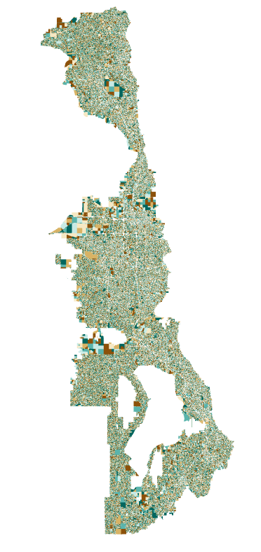

Figure 1. Regional Parcel

## Model Structure

The primary purpose of REMM is to develop regional socio-economic forecasts for the WFRC/MAG travel demand model. In addition, REMM can be used to support sub-regional and corridor analysis. We envision that it can become standard practice to use REMM for NEPA studies to understand and account for the impact of the transportation project on the subregional real estate market. Furthermore, REMM could be used to develop more robust land use and transportation plans by better understanding the impact of market forces and regulatory decisions.

REMM uses the UrbanSim modeling platform, software developed by Paul Waddell, a faculty member of the University of California, Berkeley. UrbanSim is used to simulate the broad scope of interactions among households, firms, developers and governments within markets for real estate, labor, and goods and services, as shown conceptually in the diagram below (Figure 2):

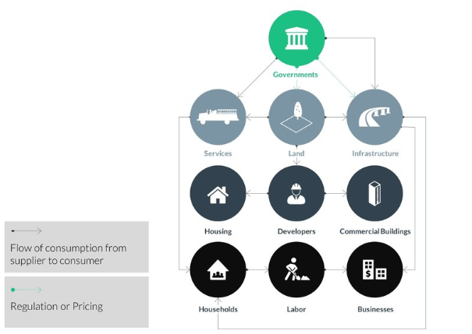

Figure 2. Real Estate Market Agents

The UrbanSim model uses submodel components to simulate the dynamics of land development, household location choice, and employment location choice. The various interdependent submodel components within UrbanSim are shown below (Figure 3).

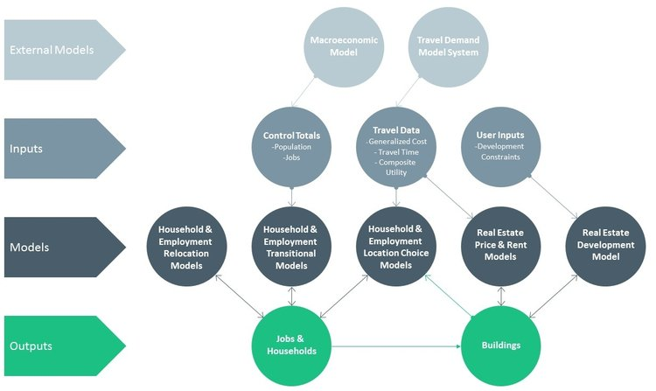

Figure 3. REMM Model FlowChart

In chapter 4-8, each of REMM’s submodels is discussed in detail, including their descriptions, estimated coefficients, calibration and validation.

# Input Database Development

In the REMM, parcel is the minimum spatial analysis unit. The parcel table is processed from annual county assessor tax parcel GIS data as shown in Figure 4 below. Households and jobs in the model are attached to residential and commercial buildings. Building-level summary information, zoning capacities, and other restrictions stored in a region-wide land use policy GIS layer are attached to the parcel table. REMM parcels are also linked to an openstreetmap network to perform neighborhood network analysis. Each REMM parcel has a parent TAZ identifier, so the dataset can be aggregated at TAZ-level and exported to the travel demand model. TAZ-level travel demand model outputs are also used as input parameters for REMM’s price, location choice, and developer models.



Figure 4. REMM Input Data Tables’ Relationship

## County Assessor Parcels

The parcel table was originally created from 2012 County Assessor parcel data of Weber, Davis, Salt Lake, and Utah Counties. In order to improve the plausibility of model results, the geometry of parcels larger than five acres have been split into smaller parcels, using a grid, in four instances:

* All vacant parcels with development potential
* Parcels along Salt Lake county’s West Bench
* Parcels in Salt Lake county’s northwest quadrant
* Agricultural areas in Utah county

For each resultant parcel, 66 variables are calculated from the initial input data. Thirty-nine of these variables are static input we processed directly from the assessor database or calculated through GIS-based spatial overlay with other layers. Other variables are calculated using custom python code that considers multiple input data items for each model year.

The following table 1 shows the attribute columns of the parcel table. The static columns stored in an .hdf5 file (won’t be updated each year during the model run) are shaded.

Table 1. Parcel Attributes

| Column Name | Data Type | Note |
| --- | --- | --- |
| parcel_id | int64 | Index Column |
| county_id | int64 | REMM County ID (1 Davis, 2 Salt Lake, 3 Weber, 4 Utah) |
| zone_id | int32 | TDM TAZ ID |
| parcel_acres | float64 | Acreage of the Parcel |
| land_value | float64 | 2011 Assessed Land Value of the Parcel |
| x | float64 | X Coordinate of the Centroid (NAD83_Utah_Central_ft) |
| y | float64 | Y Coordinate of the Centroid (NAD83_Utah_Central_ft) |
| elevation | float64 | Parcel Elevation |
| fwy_exit | float64 | Dummy Variable, If the Parcel is Freeway Exit |
| airport | float64 | Dummy Variable, If the Parcel is Airport |
| rail_depot | float64 | Dummy Variable, If the Parcel is Rail Depot |
| stream | float64 | Dummy Variable, If the Parcel is Stream |
| trail | float64 | Dummy Variable, If the Parcel is Trail |
| university | float64 | Dummy Variable, If the Parcel is University |
| shape_area | float64 | Sqft of the Parcel |
| volume_one_way | float64 | 2011 Travel Model One Way Volume (Abandoned) |
| volume_two_way | float64 | 2011 Travel Model Two Way Volume (Abandoned) |
| airport_distance | float64 | Distance to the Nearest Airport Parcel |
| fwy_exit_dist | float64 | Distance to the Nearest Freeway Exit Parcel |
| raildepot_dist | float64 | Distance to the Nearest Rail Depot Parcel |
| university_dist | float64 | Distance to the Nearest University Parcel |
| trail_dist | float64 | Distance to the Nearest Trail Parcel |
| stream_dist | float64 | Distance to the Nearest Stream Parcel |
| train_station | float64 | Dummy Variable, If the Parcel is Train Station |
| rail_stn_dist | float64 | Distance to the Nearest Train Station Parcel |
| bus_rte_dist | float64 | Distance to the Nearest Bus Route Parcel |
| bus_stop | float64 | Dummy Variable, If the Parcel is Bus Stop |
| bus_stop_dist | float64 | Distance to the Nearest Bus Stop Parcel |
| volume_two_way_nofwy | float64 | 2011 Travel Model Two Way Volume without Freeway (Abandoned) |
| distsml_id | int64 | Small District ID of the Parcel |
| distmed_id | int64 | Medium District ID of the Parcel |
| distlrg_id | int64 | Large District ID of the Parcel |
| parent_parcel | int64 | Parcel ID index before splitting |
| CO_NAME | object | County Name got from TAZ template |
| parcel_id_REMM | int64 | Index Column for Joining |
| county_taz_id | int64 | USTM County TAZ ID got from TAZ template |
| utmxi | float64 | UTM X Coordinate of the Centroid |
| utmyi | float64 | UTM Y Coordinate of the Centroid |
| city | object | City of the Parcel |
| total_job_spaces | float64 | Total Job Spaces in the Parcel |
| total_sqft | float64 | Total Building Square Feet within the Parcel |
| lot_size_per_unit | float64 | Parcel Size Divided by Residential Units |
| parcel_volume | float64 | Two Way Volume Kernel Density Calculated from Arterial Volume Shapefile |
| agriculture | float64 | Dummy Variable, If the Parcel can Have Agriculture Jobs |
| distlrg_res_shift | float64 | Large District Calibration Factor for Residential Projects |
| max_far | float64 | Maximum Floor Area Ratio Allowed by Policy |
| max_dua | float64 | Maximum Dwelling Units per Acre Allowed by Policy |
| building_purchase_price | float64 | Price to Demolish the Building |
| avg_building_age | float64 | Average Building Age in the Parcel |
| building_purchase_price_sqft | float64 | TAZ Level Average Residential Price per square foot |
| zoned_du | int32 | Allowed Dwelling Units by Policy |
| ave_unit_size | float64 | Same as ave_sqft_per_unit |
| fwy_exit_dist_tdm_output | float64 | Distance to Nearest Freeway Exit From Travel Model (Unit mile) |
| max_height | int64 | Maximum Height Allowed by Policy |
| parcel_size | float64 | Same as shape_area, parcel sqft |
| node_id | int64 | Nearest Openstreetmap Node ID |
| distlrg_nonres_shift | float64 | Large District Calibration Factor for Non Residential Projects |
| ave_sqft_per_unit | float64 | Average residential building sqft per unit within 1500 meters |
| residential_sales_price_sqft | float64 | TAZ level 75% residential price per square foot |
| total_residential_units | float64 | Total residential units in the parcel |
| land_cost | float64 | building_purchase_price + land value |
| residential_purchase_price_sqft | float64 | TAZ Level Average Residential Price per Sqft |
| gridID | float64 | GRIDID equivalency for Utility Constraint |
| zoned_du_underbuild | float64 | zoned_du-residential units, remaining residential capacity |
| redev_friction | float64 | Redevelopment Friction Factor applied to land cost |
| oldest_building | float64 | Minimum year of built |

The most recent REMM base year (2015) has 841,684 processed parcels in total. They are the basic spatial analysis unit for the entire model. Every decision event of the model results in a new object or an update to an object that is linked directly to a specific parcel. In other words, the final outcome of the model is to assign a parcel to every household, job, and building based on a calibrated set of rules. All model objects can be summarized at the parcel level, although the primary driver for WFRC/MAG is to summarize the parcel-level model results at the TAZ-level.

## Buildings Table

Every building in the model is linked to a specific parcel, and each building acts as a container for households and jobs. The base building table was created in 2012 as a 2011 base year, and it was updated to a 2015 base year in 2017. REMM’s building table is composed of the original 2011 residential base buildings, residential buildings constructed between the 2012-2015 period, and commercial buildings for 2015. There was also a process to fix errors in the 2011 base year buildings discovered while updates were made to the model’s 2015 base year.

Each building in the base year dataset was assigned one of eight building types used by the model (shown below). But only buildings with building_type_id equals 1 to 5 can be built by REMM when the model runs.

Table 2. Building Type

| building_type_id | Building Type |
| --- | --- |
| 1 | Single Family Residential |
| 2 | Multi Family Residential |
| 3 | Industrial, Warehouse & Storage |
| 4 | Retail |
| 5 | Office |
| 6 | Government and Education |
| 7 | Mixed Use |
| 8 | Other |

**Notes on Base Year Parcel Data Preparation:**

* The units of 2011 base residential buildings were checked at the TAZ level against housing unit counts from the 2010 census, and minor adjustments were made where discrepancies were found;
* The initial residential 2011 base year layer was updated to include residential buildings constructed between 2012 and 2015, which was detected (built year between 2012-2015) from 2017 county assessor GIS data;
* Some occasional misclassifications of commercial buildings as residential were found in the 2011 base year and were fixed;
* Residential unit counts for the 2015 were checked at the TAZ-level with census counts and building permit layers.
* With the 2017 county assessor GIS data, the pre-2016 commercial building inventory was used to construct a 2015 base year commercial building table.
* The job space of the 2015 base commercial buildings was checked for plausibility at TAZ level against geocoded job counts from the Department of Workforce Services.

After the collecting and updating process to 2015 base year, there are 667,293 records in the buildings table, 543,222 of which are single family building records. The table also contains 86,845 multifamily records and 37,226 commercial records. Each building record has 108 attributes, and 14 of those attributes are static and stored in hdf5 files. Most static attributes’ data come from county assessor database, except that the job spaces and the building square feet of nonresidential buildings are calculated from a special process, which will be introduced in the job table section later in this document. Other attributes are calculated by processing the static columns and joining parcel, TAZ, and district information to the building table. The table below shows the data dictionary for the REMM building table, and the static columns are highlighted.

In addition to base year building table, we have another building table built from Coldwell Banker Real Estate LLC (CBRE) just for nonresidential building price model estimation purposes. We have total 6,930 samples with rent per square foot, and we calculated values for the same 108 attributes for each of the CBRE data samples.

Table 3. Building Table Attributes

| Column Name | Data Type | Note |
| --- | --- | --- |
| building_id | int64 | Index Column |
| building_sqft | float64 | Total Building Sqft of the Building |
| building_type_id | int64 | Building Type, 1 Single Family 2 Multi Family 3 Industrial 4 Retail 5 Office 6 Government and Education 7 Mixed Use 8 Other |
| non_residential_sqft | float64 | Non Residential Sqft of the Building |
| note | object | Indicate If the Building is Base Year Building or Simulated Building |
| parcel_id | int64 | Foreign Key to the Parcel Table |
| residential_units | float64 | Residential Units of the Building, as Households Container |
| stories | int64 | Stories of the Building (Not used) |
| unit_price_non_residential | float64 | Commercial Rent per Sqft Based on Coldwell Banker Data |
| year_built | int64 | Assessed Year of Built of the Building |
| res_price_per_sqft | float64 | Residential Value per Sqft Based on 2011 Assessed Value |
| job_spaces | int64 | Job Spaces of the Building as Jobs Container |
| residential_price | int64 | Total Residential Assessed Value (Not Used) |
| non_residential_price | int64 | Total Commercial Assessed Value (Not Used) |
| distmed_32 | int32 | Dummy Variable, If the Building is in Medium District 32 |
| distmed_33 | int32 | Dummy Variable, If the Building is in Medium District 33 |
| distmed_30 | int32 | Dummy Variable, If the Building is in Medium District 30 |
| distmed_31 | int32 | Dummy Variable, If the Building is in Medium District 31 |
| distmed_36 | int32 | Dummy Variable, If the Building is in Medium District 36 |
| distmed_37 | int32 | Dummy Variable, If the Building is in Medium District 37 |
| distmed_34 | int32 | Dummy Variable, If the Building is in Medium District 34 |
| distmed_35 | int32 | Dummy Variable, If the Building is in Medium District 35 |
| distmed_38 | int32 | Dummy Variable, If the Building is in Medium District 38 |
| distmed_39 | int32 | Dummy Variable, If the Building is in Medium District 39 |
| is_office | int32 | Dummy Variable, If the building is Office Building |
| bus_stop_dist | float64 | Building's Parcel Distance to Bus Stop |
| elevation | float64 | Building's Parcel Elevation |
| distmed_med_inc | float64 | Median Income of the Corresponding Medium District |
| distmed_21 | int32 | Dummy Variable, If the Building is in Medium District 21 |
| distmed_20 | int32 | Dummy Variable, If the Building is in Medium District 20 |
| distmed_23 | int32 | Dummy Variable, If the Building is in Medium District 23 |
| distmed_22 | int32 | Dummy Variable, If the Building is in Medium District 22 |
| distmed_25 | int32 | Dummy Variable, If the Building is in Medium District 25 |
| distmed_24 | int32 | Dummy Variable, If the Building is in Medium District 24 |
| distmed_27 | int32 | Dummy Variable, If the Building is in Medium District 27 |
| distmed_26 | int32 | Dummy Variable, If the Building is in Medium District 26 |
| distmed_29 | int32 | Dummy Variable, If the Building is in Medium District 29 |
| distmed_28 | int32 | Dummy Variable, If the Building is in Medium District 28 |
| distlrg_id | int64 | Large District ID of Building's Parcel |
| trail_dist | float64 | Building's Parcel's Distance to Nearest Trail |
| raildepot_dist | float64 | Building's Parcel's Distance to Nearest Rail Depot |
| lot_size_per_unit | float64 | Lot Size per Unit for Building's Parcel |
| distmed_14 | int32 | Dummy Variable, If the Building is in Medium District 14 |
| distmed_15 | int32 | Dummy Variable, If the Building is in Medium District 15 |
| distmed_16 | int32 | Dummy Variable, If the Building is in Medium District 16 |
| distmed_17 | int32 | Dummy Variable, If the Building is in Medium District 17 |
| distmed_10 | int32 | Dummy Variable, If the Building is in Medium District 10 |
| distmed_11 | int32 | Dummy Variable, If the Building is in Medium District 11 |
| distmed_12 | int32 | Dummy Variable, If the Building is in Medium District 12 |
| distmed_13 | int32 | Dummy Variable, If the Building is in Medium District 13 |
| utmyi | float64 | UTM Y Coordinate of the Parcel Centroid |
| distmed_18 | int32 | Dummy Variable, If the Building is in Medium District 18 |
| distmed_19 | int32 | Dummy Variable, If the Building is in Medium District 19 |
| distmed_2 | int32 | Dummy Variable, If the Building is in Medium District 2 |
| distmed_3 | int32 | Dummy Variable, If the Building is in Medium District 3 |
| distmed_1 | int32 | Dummy Variable, If the Building is in Medium District 1 |
| distmed_6 | int32 | Dummy Variable, If the Building is in Medium District 6 |
| distmed_7 | int32 | Dummy Variable, If the Building is in Medium District 7 |
| distmed_4 | int32 | Dummy Variable, If the Building is in Medium District 4 |
| distmed_5 | int32 | Dummy Variable, If the Building is in Medium District 5 |
| airport_distance | float64 | Building's Parcel's Distance to Nearest Airport |
| distmed_8 | int32 | Dummy Variable, If the Building is in Medium District 8 |
| distmed_9 | int32 | Dummy Variable, If the Building is in Medium District 9 |
| is_sf | int32 | Dummy Variable, If the building is Single Family Building |
| improvement_value | float64 | Assessed Improvement Value of the Building |
| utmxi | float64 | UTM X Coordinate of the Parcel Centroid |
| rail_stn_dist | float64 | Building's Parcel's Distance to Nearest Train Station |
| parcel_acres | float64 | Acreage of the Building's Parcel |
| stream_dist | float64 | Building's Parcel's Distance to Nearest Stream |
| is_govt | int32 | Dummy Variable, If the building is Government and Education Building |
| zone_id | int32 | TAZ ID of the Building's Parcel |
| volume_two_way_nofwy | float64 | Building's Parcel 2011 Travel Model Two Way Volume without Freeway (Abandoned) |
| is_retail | int32 | Dummy Variable, If the building is Retail Building |
| airport | float64 | Dummy Variable, If the Building's Parcel is Airport |
| general_type | object | Get Text Version of Building Type |
| fwy_exit_dist | float64 | Distance to the Nearest Freeway Exit Parcel |
| total_job_spaces | float64 | Total Job Spaces in the Building's Parcel |
| is_mf | int32 | Dummy Variable, If the building is Multifamily Building |
| real_far | float64 | Building's Floor Area Ratio (Building Sqft / Parcel Sqft) |
| residential_sqft | float64 | Sqft per Unit Multiplied by Residential Units |
| max_far | float64 | Maximum Floor Area Ratio Allowed by Policy |
| is_mixeduse | int32 | Dummy Variable, If the building is Mixed Used Building |
| avg_building_age | float64 | Average Building Age in the Building's Parcel |
| distmed_id | int64 | Medium District ID of the Building's Parcel |
| residential_sales_price_sqft | float64 | TAZ level 75% residential price per sqft |
| sqft_per_job | int64 | Get Sqft per Job from Settings for Corresponding Building Type |
| zone_1212 | int32 | Dummy Variable, If it is Copperton 1386 TAZ |
| volume_two_way | float64 | Building's Parcel 2011 Travel Model Two Way Volume(Abandoned) |
| sqft_per_unit | float64 | Building Sqft Divided By Residential Unit |
| university_dist | float64 | Building's Parcel's Distance to Nearest University |
| parcel_volume | float64 | Building's Parcel Two Way Volume Kernel Density Calculated from Arterial Volume Shapefile |
| vacant_residential_units | float64 | Vacant Residential Units in the Building |
| county_id | int64 | County ID of Building's Parcel |
| distsml_id | int64 | Small District ID of Building's Parcel |
| is_industrial | int32 | Dummy Variable, If the building is Industrial Building |
| vacant_job_spaces | float64 | Vacant Job Spaces in the Building |
| bus_rte_dist | float64 | Building's Parcel's Distance to Nearest Bus Route |
| building_age | int64 | Age of the Building |
| distlrg_med_inc | float64 | Median Income of the Corresponding Large District |
| distmed_41 | int32 | Dummy Variable, If the Building is in Medium District 41 |
| distmed_40 | int32 | Dummy Variable, If the Building is in Medium District 40 |
| land_value | float64 | 2011 Assessed Land Value of Building's Parcel |
| node_id | int64 | Nearest Openstreetmap Node ID of Building's Parcel |
| unit_price_residential | float64 | Improvement Value Divided by Residential Units |
| distsml_med_inc | float64 | Median Income of the Corresponding Small District |
| fwy_exit_dist_tdm_output | float64 | Distance from Building's Parcel to Nearest Freeway Exit From Travel Model (Unit mile) |
| rail_depot | float64 | Dummy Variable, If the Building's Parcel is Rail Depot |
| is_other | int32 | Dummy Variable, If the building is Other Building |

## Households Table

Rows in the REMM households table represent households within our modeling area. The households table was first created through population synthesizer based on data from the 2010 Census and American Community Survey, including: population, cars, workers, race, age, and children information. After updating the building table to 2015, REMM’s household location choice model was used to fill residential buildings with households. Household totals were checked against the county-level household control totals released by the University of Utah’s Gardner Policy Institute (GPI). Household totals were also checked against the census tract level vacancy rate indicated by American Community Survey. Areas found to exceed the expected household numbers had households randomly removed until modeled data matched control totals and census vacancy rates. At the completion of this process, the 2015 base year had 731,392 total households, all assigned to a residential building within REMM. In the end, incomes were adjusted based on the census tract level median household income obtained from the American Community Survey. The final household table has 23 attributes. Thirteen of them were generated by population synthesizer and adjusted based on American Community Survey data. Other attributes are calculated based on the static columns, or the information joined through the building, parcel, TAZ, and district information attached to the households.



Figure 5. 2015 Base Year Household Table Preparation Process

Table 4. Household Table Attributes

| Column Name | Data Type | Note |
| --- | --- | --- |
| households_id | int64 | Index Column |
| cars | int64 | Number of Cars Owned by the Household |
| household_type_id | int64 |  |
| persons | int64 | Number of Household Population |
| income | float64 | Income of the Household |
| workers | int64 | Number of Workers of the Household |
| children | int64 | Number of Childrens of the Household |
| age_of_head | int64 | Age of Household Head |
| race_id | int64 | Race of the Household |
| familyhh | int64 |  |
| block_id | int64 | Census Block ID |
| cid | int64 | County Control Total ID |
| building_id | int32 | Attached Building ID |
| distsml_id | int32 | Small District ID of the Household's Parcel |
| proportion_workers | float64 | Proportion of Workers of the Household |
| zone_id | int32 | TAZ ID of the Household's Parcel |
| distmed_id | int32 | Medium District ID of the Household's Parcel |
| parcel_id | int32 | Parcel ID of the Household's Parcel |
| b_year_built | int32 | Year of Built of Household's Building |
| node_id | int32 | Node ID of the Household's Parcel |
| income_quartile | int32 | Income Quartile of the Household |
| county_id | int32 | County ID of the Household's Parcel |
| distlrg_id | int32 | Large District ID of the Household's Parcel |

## Jobs Table

Each record of the REMM jobs table represents a non-home-based job in our modeling area, and it is attached to a non-residential building in the building table. The initial source for the jobs table was geocoded 2011 employment data from the Utah Department of Workforce Services (DWS). When updating the base year to 2015, the jobs tables was recreated based on geocoded 2015 DWS data. Avenue Consultants, Inc. geocoded 2015 DWS points. DWS data points were spatially evaluated for accuracy and cleaned as needed. When data points fell close to TAZ boundaries decisions were made based upon control totals and reasonableness to assign the data to the appropriate geography. If the DWS points are geocoded to a residential parcel and there are less than three jobs, they were marked as home-based job and removed them from the dataset. The commercial building table was compared with DWS point data at the TAZ-level to detect and solve discrepancies. Each commercial building was given a job space value later based on the TAZ-level DWS count, county-level job control totals and professional judgement. Finally, a gravity model was used to assign DWS data points a building ID based on the job space of the commercial building (attractiveness) and Euclidean distance to the building (see Figure 6).

In the end, the REMM employment location choice model was used to fill the rest of the commercial buildings with jobs to reach county-level job control totals. After this process a total of 1,295,513 records were in the jobs table. The jobs table has 13 static fields derived from the DWS data with its job sector linked to the company NAICS code. Other attributes include the information joined through the building, parcel, TAZ, and district information attached to the households.



Figure 6. 2015 Base Year Job Table Preparation

As part of the 2015 REMM base year update, it was decided to remove construction and mining jobs from this jobs allocation process and use other methods to determine their location. Construction jobs, home-based jobs, agriculture jobs, and mining jobs are still in the county job control table from GPI county-level forecast, and they are allocated later, at the TAZ-level when REMM is exporting data to the TDM. Construction jobs are allocated to each TAZ based on the number of new building square feet built in each TAZ during that model year. Home-based jobs are allocated to TAZs based on the number of households in each TAZ in that model year. The allocation of mining jobs and agriculture jobs will be introduced in Section 3.10, which is based on TAZ-level mining and agriculture input.

Table 5. Job Sector ID Definition Table

| sector_id | Job Type |
| --- | --- |
| 1 | Accommodation, Food Services |
| 2 | Construction (Out of Table) |
| 3 | Government and Education |
| 4 | Health Care |
| 5 | Manufacturing |
| 6 | Office |
| 7 | Other |
| 8 | Mining (Out of Table) |
| 9 | Retail Trade |
| 10 | Wholesale, Transport |
| 11 | Agriculture (Out of Table) |
| 12 | Home-based Job (Out of Table) |

[Add this table/graphic, perhap as an appendix?]

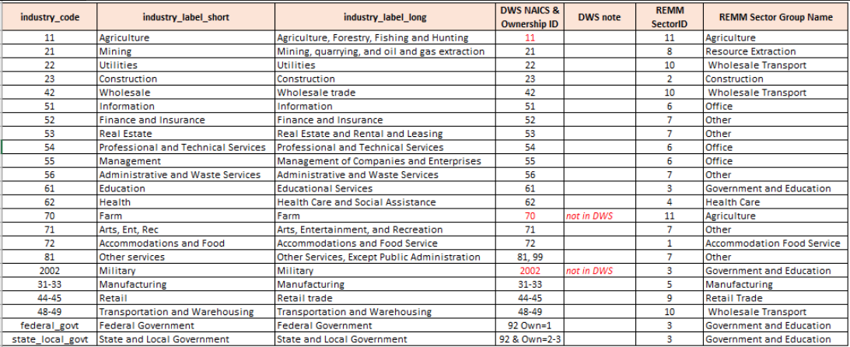

Table 6. Jobs’ Attributes

| Column Name | Data Type | Note |
| --- | --- | --- |
| jobs_id | int64 | Index Column |
| sector_id | int64 | Job Sector ID |
| building_id | int64 | Attached Building ID |
| cid | int64 | County Control Total ID |
| distsml_id | int32 | Small District ID of the Job's Parcel |
| zone_id | int32 | TAZ ID of the Job's Parcel |
| distmed_id | int32 | Medium District ID of the Job's Parcel |
| parcel_id | int32 | Parcel ID of the Job's Parcel |
| b_year_built | int32 | Built of Job's Building |
| node_id | int64 | Node ID of the Job's Parcel |
| county_id | int32 | County ID of the Job's Parcel |
| building_type_id | int32 | Building Type ID of Job's Building |
| distlrg_id | int32 | Large District ID of the Job's Parcel |

## Land Use Policy Table

The land use policy layer was translated to parcels from 2012 city land use general plans. If a city did not have a general land use plan or their existing plans did not have sufficient information, the city’s zoning map was used to generate the land use policy layer for that city. For some areas with high development potential but lacking detailed plan information, such as the Benjamin agriculture area in southern Utah County or the west bench of Salt Lake County, professional judgement was used to determine future land use capacities. The land use policy layer for some areas has been temporarily staged with capacity released incrementally over time to ensure a plausible placement of development activities. A change table is utilized to reflect the future policy changes. For the 2019 Regional Transportation Plan’s preferred scenario, WFRC included local and regional “centers” to the land use policy layer. These centers were identified by local and regional stakeholders as part of the Wasatch Choice 2050 visioning exercise.

The policy layer contains two types of information: allowable density and building type. The building type is represented by eight dummy variables that indicate which of the eight building types are allowed to build on each parcel according to the policy layer. If there is a mixed use policy in place, more than one building type is allowed to be constructed in that parcel. Residential density capacities are measured using maximum dwelling units per acre (max_dua) for each parcel. Nonresidential density capacities are measured using maximum floor area ratio (max_far) for each parcel. In the REMM developer model, max_dua is transformed to max_far based on the average residential unit size of the neighborhood, which is max_far_from_dua = max_dua * unit_size(sq ft) / 43560. REMM will choose the minimum floor-to-area ratio between max_far and max_far_from_dua if both max_dua and max_far are provided. Maximum building height has not been used in the model yet but will be in the future so a default value, 999, was set as a placeholder in the table. A city’s general plan or zoning map usually has specific information about maximum dwelling units allowed per acre for residential areas. Commercial floor area ratio was usually determined by parking policy requirements. (Underground parking = 3 - 9; structured parking = 1; surface parking = 0.5). If the general plan or zoning map does not provide density constraints, professional judgement was used to determine the density.

Three external expert panels (Wasatch Front Central Corridor Study Group, Farmington Area, and American Fork Area) and Metro Analytics reviewed REMM’s 2050 output data and provided feedback to improve REMM’s land use policy layer. The following improvements have been implemented:

1. The capacity for the central Salt Lake County area was reduced and staged.
2. The capacity for the Farmington station area was staged.
3. The base capacity for the Daybreak area was updated.
4. The capacity for the American Fork station area was staged and updated
5. The capacity for the Millcreek City multi-family housing was reduced.

As part of their contracted review, Metro Analytics submitted a [technical report](https://drive.google.com/drive/u/0/folders/1cSCh5yO3SlzzAQWAGe-VZXgHHIUIeS1U) with recommendations

Table 7. Land Use Policy Attributes

| Column Name | Data Type | Note |
| --- | --- | --- |
| parcel_id | int64 | Index Column, Linked to Parcels |
| max_dua | float64 | Maximum Dwelling Units Allowed per Acre |
| max_far | float64 | Maximum Floor Area Ratio Allowed |
| type1 | object | If Single Family Building is Allowed |
| type2 | object | If Multifamily Building is Allowed |
| type3 | object | If Industrial Building is Allowed |
| type4 | object | If Retail Building is Allowed |
| type5 | object | If Office Building is Allowed |
| type6 | object | Reserved for Government and Education Buildings |
| type7 | object | Reserved for Mixed Use Buildings |
| type8 | object | Reserved for Other Buildings |
| max_height | int64 | Maximum Building Height Allowed |

## County Control Total

The GPI receives funding from the Utah Legislature to produce annual county population estimates and long run demographic and economic projections. They have yearly forecasts for number of households, population, and jobs by sectors from 2015 to 2060. We processed their county control total households, household population, and employment by sector to generate new households and jobs for each future model year. As our model area excludes the mountainous portions of Weber, Salt Lake, and Utah counties, households, population, and employment were subtracted from the GPI control totals for these areas.

## TAZ Table and Travel Model Input

The REMM version 1.0 is integrated with Wasatch Front Travel Demand Model Version 8.3. The travel demand model includes Utah, Salt Lake, Davis, Weber, and Urbanined Weber counties. This modeled area is divided into 2,881 Traffic Analysis Zones (TAZ). External TAZs, which represent trip origins and destinations outside of the travel model area, are not processed by current version of REMM.

REMM parcel-level households and jobs data are aggregated into TAZ-level households and employment by eight sectors for travel demand model. Construction, mining, agriculture, and home-based jobs are calculated based on REMM building and household table together with mining and agriculture input. TAZ level population is aggregated from the household table first, then scaled to the county-level population controls by keeping a minimum 1.5 persons per household size. Median household income and school enrollment are kept as constant in the output files. The travel model reads the socio-economic data from REMM and integrates it with Box Elder County data prepared in a separate process, as essential inputs for travel model.

In addition to creating output that the travel model needs, REMM runs the travel demand model to create generalized accessibility measures (listed below) that inform development decisions within REMM.

1. Travel time matrices (auto and transit skims from travel demand model mode choice component). Indicates travel convenience by automobile and transit between every TAZs.
2. Logsum matrices. Show the all modes’ composite convenience between each TAZs.
3. Volume shapefiles. REMM calls an ArcPy scripts to calculate a kernel density for the arterial volume, and then intersects it with the parcels to get a parcel level road volume measure.
4. Transit distances. A static file has distance to nearest transit stops/routes.
5. Freeway exit nodes. REMM translates coordinates of freeway exits based on their travel model node ID, and calculate Euclidean distance to the nearest freeway exit node for each parcel.
6. Average commute times. The TAZ level weighted average trip time for all of the home-based work trips from each TAZ.

The TDM put all these data at the 6_REMM\Ro folder of the travel model. REMM grabs these accessibility measures for the following years: 2015 (base year), 2019 (TIP), 2027 (RTP phase 1), 2035 (RTP phase 2), and 2045 (RTP phase 3).

REMM also has a TAZ table, as shown in Table 8 below, which aggregates multiple data from across the parcel and building tables at a TAZ level to describe the neighborhood information for each TAZ. The average commute time from travel model is also represented in the zone table. A lot of accessibility variables, which include households/jobs within certain minutes by automobile/transit and logsum value to households/jobs, are calculated from other TAZ level variables together with the travel model’s travel time matrices and logsum matrices.

Table 8. TAZ Attributes

| Column Name | Data Type | Note |
| --- | --- | --- |
| parcel_count | int64 | Number of Parcels within the TAZ |
| jobs_2_within_10_min | int32 | Construction Jobs within 10 Minutes By Automobile (Abandoned) |
| pop_density | float64 | TAZ Level Population Density |
| population_within_10_min | int32 | Population within 10 Minutes By Automobile |
| tdm_county_id | int64 | Travel Model Social Economic Table County ID |
| ave_age_of_head | float64 | Average Age of Household Head in the TAZ |
| population_within_40_min | int32 | Population within 40 Minutes by Automobile |
| jobs_within_30_min_transit | int32 | Jobs within 30 Minutes by Transit |
| jobs_7_within_10_min | int32 | Other Jobs within 10 Minutes by Automobile |
| ave_hhchildren_zn | float64 | Average Children per Household in the TAZ |
| jobs_1_within_10_min | int32 | Accomodation and Food Jobs within 10 Minutes by Automobile |
| logsum_jobs10 | int32 | Logsum Value to Wholesale and Transport Jobs |
| nonres_median_price | float64 | TAZ Level Median Rent per Sq Ft of Non Residential Buildings |
| population_within_40_min_transit | int32 | Population within 40 Minutes by Transit |
| res_units_within_30_min | int32 | Residential Units within 30 Minutes by Automobile |
| res_median_price | float64 | TAZ Level Median Price per Sq Ft of Residential Buildings |
| ind_median_price | float64 | TAZ Level Median Rent per Sq Ft of Industrial Buildings |
| population_within_20_min | int32 | Population Within 20 Minutes by Automobile |
| total_jobs | float64 | Total Jobs within the TAZ |
| ave_hhsize_zn | float64 | Average Household Size within the TAZ |
| jobs_9 | float64 | Total Retail Jobs within the TAZ |
| jobs_8 | float64 | Total Resource Extraction Jobs within the TAZ (Abandoned) |
| jobs_5_within_10_min | int32 | Manufacturing Jobs within 10 Minutes by Automobile |
| jobs_9_within_10_min | int32 | Retail Jobs within 10 Minutes by Automobile |
| jobs_3 | float64 | Total Government and Education Jobs within the TAZ |
| jobs_2 | float64 | Total Construction Jobs within the TAZ (Abandoned) |
| jobs_1 | float64 | Total Accommodation and Food Jobs within the TAZ |
| sum_land_value | float64 | Sum of the Land Value within the TAZ |
| ret_median_price | float64 | TAZ Level Median Rent per Square Foot of Retail Buildings |
| jobs_6 | float64 | Total Office Jobs within the TAZ |
| jobs_5 | float64 | Total Manufacturing Jobs within the TAZ |
| jobs_4 | float64 | Total Health Care Jobs within the TAZ |
| population_within_30_min | int32 | Population within 30 Minutes by Automobile |
| jobs_10 | float64 | Total Wholesale Transport Jobs within the TAZ |
| jobs_6_within_10_min | int32 | Office Jobs within 10 Minutes by Automobile |
| jobs_8_within_10_min | int32 | Resource Extraction Jobs within 10 Minutes by Automobile (Abandoned) |
| jobs_10_within_10_min | int32 | Wholesale Transport Jobs within 10 Minutes by Automobile |
| total_households | float64 | Total Households within the TAZ |
| jobs_within_15_min | int32 | Jobs within 15 Minutes by Automobile |
| ave_nonres_price_zn | float64 | TAZ Level Average Price per Sqft of Non Residential Buildings |
| seg_col | int64 | 1 |
| logsum_jobs2 | int32 | Logsum Value to Construction Jobs (Abandoned) |
| logsum_jobs3 | int32 | Logsum Value to Government and Education Jobs |
| logsum_jobs1 | int32 | Logsum Value to Accomodation, Food Service Jobs |
| logsum_jobs6 | int32 | Logsum Value to Office Jobs |
| median_income | float64 | TAZ Level Median Income of Households |
| logsum_jobs4 | int32 | Logsum Value to Health Care Jobs |
| logsum_jobs5 | int32 | Logsum Value to Manufacturing Jobs |
| land_value_per_acre | float64 | Total Land Value of the TAZ Divided by Total Parcel Acre of the TAZ |
| logsum_jobs8 | int32 | Logsum Value to Resource Extraction Jobs (Abandoned) |
| logsum_jobs9 | int32 | Logsum Value to Retail Trade Jobs |
| hh_choice_control | float64 | Household Difference from 2015 Target (For Calibration) |
| logsum_hhinc3 | int32 | Logsum Value to Households (3rd Income Quartile) |
| logsum_hhinc2 | int32 | Logsum Value to Households (2nd Income Quartile) |
| logsum_hhinc1 | int32 | Logsum Value to Households (1st Income Quartile) |
| jobs_within_20_min | int32 | Jobs within 20 Minutes by Automobile |
| jobs_within_40_min_transit | int32 | Jobs within 40 Minutes by Transit |
| logsum_jobs7 | int32 | Logsum Value to Other Jobs |
| logsum_hhinc4 | int32 | Logsum Value to Households (4th Income Quartile) |
| ave_hhpropwkrs_zn | float64 | TAZ Level Average Household Proportion of Workers |
| jobs_4_within_10_min | int32 | Health Care Jobs within 10 Minutes by Automobile |
| population_within_15_min | int32 | Population within 15 Minutes by Automobile |
| logsumjobs | int32 | Logsum Value to Jobs |
| logsumpopulation | int32 | Logsum Value to Population |
| population | float64 | Total Population within the TAZ |
| ofc_median_price | float64 | TAZ Level Median Rent per Sqft of Office Buildings |
| jobs_within_20_min_transit | int32 | Jobs within 20 Minutes by Transit |
| jobs_3_within_10_min | int32 | Government and Education Jobs within 10 Minutes by Automobile |
| jobs_within_30_min | int32 | Jobs within 30 Minutes by Automobile |
| commute_time | float64 | Average Commute Time for the Commuters Live in the TAZ |
| commute_time_20 | float64 | Absolute Difference between Average Commute Time and 20 Minutes |
| population_within_20_min_transit | int32 | Population within 20 Minutes by Transit |
| jobs_7 | float64 | Total Other Jobs within the TAZ |
| res_units_within_20_min | int32 | Residential Units within 20 Minutes by Automobile |
| ave_hhincome_zn | float64 | TAZ Level Average Household Income |
| ave_res_price_zn | float64 | TAZ Level Average Price per Sqft of Residential Buildings |
| building_age_zn | float64 | TAZ Level Average Building Age |
| hh_target_2015 | int64 | Target Total 2015 households within the TAZ |
| population_within_30_min_transit | int32 | Population within 30 Minutes by Transit |
| jobs_within_10_min | int32 | Jobs within 10 Minutes by Automobile |
| ave_hhcars_zn | float64 | TAZ Level Average Household Cars |

## Node Table and OpenStreetMap Input

UrbanSim uses a Python package, Pandana, to perform network analysis. Pandana performs hundreds of thousands of network queries in under a second (for walking-scale distances) using a Pandas-like API. The computations are parallelized for use on multi-core computers using an underlying C library.

REMM loads an openstreetmap network into the Pandana network dataframe and links it to the parcels. Thus, in every model year, REMM calculates some openstreetmap based accessibility variables with the network data for each parcel or building. The definition of the network variables are located in configs/neighborhood_vars.yaml.

## Redevelopment Friction

REMM does not have an appropriate variable to consider a demolishing cost and policy cost of redevelopment. Therefore, a friction factor variable was introduced for each parcel to account for this. When the developer model calculates cost for redevelopment, the land cost (which includes land value plus building purchase cost) is multiplied by this friction variable.

Most of the model area has a default friction value of 5. Utah County has a default value of 10. Part of historical downtown Salt Lake City has a special value of 100 to preserve historic districts like The Avenues district. West Weber County has a special value of 5,000 to preserve the factories there.

## Agriculture and Mining Input

Agriculture and mining jobs are allocated differently from other job sectors. The travel model export function of REMM dealt with these jobs based on two input layers together with other TAZ level aggregated variables, as explained below.

Agriculture jobs are allocated based on a parcel level agriculture layer, which is originally from the Water Related Land Use layer hosted by the Utah Automated Geographic Reference Center for the Utah Division of Water Resources. This layer is a water usage-related polygon map dataset that depicts the types and extent of irrigated crops, as well as information concerning phreatophytes, wet/open water areas, dry land agriculture and residential/industrial areas. Polygons were identified that can have agriculture jobs based on Table 9.

Table 9. Water Based Agriculture Land Use Type

| Land Use Type | Acres | Agriculture Jobs |
| --- | --- | --- |
| Alfalfa | 42595.54 | yes |
| Beans | 118.2282 | yes |
| Berries | 31.87973 | yes |
| Corn | 16117.43 | yes |
| Dry Alfalfa | 1626.385 | yes |
| Dry Grain | 91.04747 | yes |
| Dry Grain/Seeds | 9333.5 | yes |
| Dry Land | 89834.47 | no |
| Dry Oats | 48.20858 | yes |
| Dry Safflower | 119.5029 | yes |
| Fallow-Irrigated Ag | 692.3063 | yes |
| Fallow-Irrigated Land | 815.8625 | yes |
| Grain | 12067.55 | yes |
| Grass Hay | 10981.06 | yes |
| GrassHay-SubIrrigated | 964.0953 | yes |
| Idle-Irrigated Ag | 5312.724 | no |
| Idle-Irrigated Land | 14270.05 | no |
| IdleIrrigatedPasture | 9614.117 | no |
| Melon/Pumpkin/Squash | 752.2271 | yes |
| Oats | 1145.908 | yes |
| Onions | 607.4571 | yes |
| Orchard | 6484.325 | yes |
| Other Horticulture | 219.5884 | yes |
| Other Vegetables | 439.1441 | yes |
| Pasture | 33789.62 | no |
| Pasture-SubIrrigated | 23401.86 | no |
| Potatoes | 77.38511 | yes |
| Riparian | 20192.66 | no |
| Safflower | 92.94938 | yes |
| Sewage Lagoon | 656.9805 | no |
| Sorghum | 53.02456 | yes |
| Tomatoes | 135.4644 | yes |
| Turf Farms | 1236.264 | yes |
| Urban | 295152.6 | no |
| Urban Grass | 5808.944 | no |
| Urban Grass/Parks | 12688.89 | no |
| Urban/Urban Idle | 126152.5 | no |
| Vineyard | 15.65899 | yes |
| Water | 94906.1 | no |
| Wet Flats | 19487.52 | no |

REMM sums the area of undeveloped agriculture parcels in each TAZ, and allocates county-level agriculture jobs proportionally to these areas.

The Utah State Tax Commission provides the active mines dataset for our modeling area. Base year mining jobs were allocated to those mines by professional judgement. The portion of mining jobs assigned to each mine will be scaled according to changes to the county-level controlled total for mining jobs.

Table 10. Mining Company Name and Location

| Operator Name | Mine Name | Minerals | UTM X Coordinate | UTM Y Coordinate |
| --- | --- | --- | --- | --- |
| Earth's Elements Inc | Earth's Elements-Evap Ponds | Brine | 374715 | 4568182 |
| Roger | Bottleneck Pit | Sand & Gravel | 381621 | 4567476 |
| Oakley Mountain Corp | Green Beetle Quartzite Tract | Quartzite | 281724 | 4611682 |
| Gold Star Stone Inc | Sierra Starlight Quarry | Quartzite | 267970 | 4645340 |
| Star Stone Quarries Inc | Cotton Thomas | Stone | 267666 | 4643900 |
| Sawtooth Stone LLC | Sawtooth Stone No. 1 | Quartzite | 267743 | 4642798 |
| Gold Star Stone Inc | Lone Pine | Quartzite | 269217 | 4641578 |
| Todd Erickson Stone Inc | Lynn Pass Quarry | Stone | 270770 | 4639532 |
| Bonneville Quarries Inc | Lynn Spring Quarry | Stone | 275574 | 4644007 |
| Oakley Mountain Corp | Dove Creek Quarry | Flagstone | 279836 | 4636606 |
| Bonneville Quarries Inc | Clark Basin-South Quarry | Quartzite | 280048 | 4636254 |
| James Cleon Peterson | Henrietta 21 | Quartzite | 280339 | 4635647 |
| Northern Stone Supply Inc | Turquoise Stone | Stone | 302182 | 4636563 |
| North Shore Limited Partnership | NorthShore Natural Processing | Magnesium Chloride | 344753 | 4618370 |
| Staker & Parson Companies Inc | Holdaway Aggs Pit | Sand & Gravel | 395747 | 4622168 |
| Mel Kupfer Construction | Bothwell Pit | Sand & Gravel | 389861 | 4618335 |
| Granite Construction Company | Promontory | Limestone, Gravel | 395077 | 4605921 |
| Geneva Rock Products Inc | Corinne Pit | Sand & Gravel | 395920 | 4603906 |
| Kilgore Companies LLC | Plymouth Pit | Sand & Gravel | 403222 | 4639836 |
| Whitaker Construction Inc | Plymouth Pit | Sand & Gravel | 403413 | 4638822 |
| Landis Construction LLC | Collinston Pit | Sand & Gravel | 407992 | 4622868 |
| Rupp Trucking & Enterprises Inc | N Deweyville Pit | Sand & Gravel | 408862 | 4622281 |
| Circle C Construction Inc | N Deweyville Pit | Sand & Gravel | 409036 | 4622571 |
| Grover Excavation | Deweyville Pit | Sand & Gravel | 408776 | 4620723 |
| Staker & Parson Companies Inc | Honeyville Aggs Pit | Sand & Gravel | 410067 | 4613133 |
| Kilgore Companies LLC | Honeyville Pit | Sand & Gravel | 410966 | 4609781 |
| Box Elder County | Honeyville Pit | Sand & Gravel | 410966 | 4609544 |
| Northshore Rock Products LLC | Honeyville Pit | Sand & Gravel | 412238 | 4607287 |
| Staker & Parson Companies Inc | Backus Aggs Pit | Sand & Gravel | 411864 | 4607849 |
| Staker & Parson Companies Inc | Brigham Aggs Pit | Sand & Gravel | 416635 | 4595662 |
| Kilgore Companies LLC | Brigham City Pit | Sand & Gravel | 416771 | 4594855 |
| Staker & Parson Companies Inc | Brigham South Aggs Pit | Sand & Gravel | 416584 | 4594625 |
| Geneva Rock Products Inc | Perry Pit | Sand & Gravel | 414074 | 4590068 |
| Granite Construction Company | Willard Pit | Sand & Gravel | 414130 | 4585842 |
| Pine Ridge Excavation & Landscape | Pine Ridge Rock | Boulders | 428654 | 4582820 |
| Towers Sand & Gravel LLC | Hinkley Dr Pit | Sand & Gravel | 414436 | 4561682 |
| Towers Sand & Gravel LLC | Towers Sand & Gravel - LMO | Sand & Gravel | 415362 | 4576892 |
| Staker & Parson Companies Inc | Rocky Point Gravel Mine | Sand & Gravel | 413960 | 4577116 |
| Compass Minerals Ogden Inc | GSL | Salt | 396515 | 4570644 |
| Geneva Rock Products Inc | West Weber Gravel Pit | Sand & Gravel | 397010 | 4567190 |
| Staker & Parson Companies Inc | South Weber Aggs Pit | Sand & Gravel | 423272 | 4553622 |
| Geneva Rock Products Inc | South Weber Pit | Sand & Gravel | 423914 | 4553951 |
| Craythorne Inc | E Layton Pit | Sand & Gravel | 423970 | 4546986 |
| Lakeview Rock Products Inc | Thomas Pit | Sand & Gravel | 422995 | 4520221 |
| Lakeview Rock Products Inc | Beck Street Quarry | Sand & Gravel | 422958 | 4519372 |
| Staker & Parson Companies Inc | Beck Street Pit | Sand & Gravel | 422902 | 4518298 |
| Utah Sand And Gravel | North Salt Lake | Sand & Gravel | 423655 | 4516654 |
| Kilgore Companies LLC | Parley's Canyon Rock Quarry | Sand & Gravel | 434825 | 4508778 |
| Granite Construction Company | Big Cottonwood Canyon Pit | Sand & Gravel | 432770 | 4497568 |
| Kilgore Companies LLC | West Valley Pit | Sand & Gravel | 411242 | 4500433 |
| Staker & Parson Companies Inc | Reynolds Pit #2 | Sand & Gravel | 410484 | 4500446 |
| Geneva Rock Products Inc | West Valley Pit | Sand & Gravel | 411260 | 4499596 |
| Strang Excavating Inc | 5400 S 7800 W Pit | Sand & Gravel | 409667 | 4500708 |
| Strang Excavating Inc | U111 @ 5422 S Pit | Sand & Gravel | 408760 | 4500298 |
| TM Crushing LLC | Glenwood Pit | Sand & Gravel | 410322 | 4497850 |
| Bland Recycling LLC | West Valley Pit | Sand & Gravel | 410880 | 4496889 |
| TM Crushing LLC | U111 @ 7800 S Pit | Sand & Gravel | 409998 | 4496060 |
| Staker & Parson Companies Inc | Reynolds Pit #1 | Sand & Gravel | 409779 | 4494714 |
| Sorensen Sand & Gravel | New Bingham Hwy @ 7382 W Pit | Sand & Gravel | 408888 | 4491739 |
| Staker & Parson Companies Inc | Beef Hollow Quarry | Sand & Gravel | 417767 | 4480006 |
| Asphalt Material Inc | Bluffdale Pit | Sand & Gravel | 421934 | 4478409 |
| Kilgore Companies LLC | Salt Lake Valley Pit | Sand & Gravel | 421904 | 4478999 |
| Geneva Rock Products Inc | Point of Mountain (So Hansen) Pit | Sand & Gravel | 422063 | 4479948 |
| Staker & Parson Companies Inc | Point of the Mountain Pit | Sand & Gravel | 422974 | 4479053 |
| Staker & Parson Companies Inc | Point of the Mountain (West) Pit | Sand & Gravel | 422192 | 4477477 |
| Geneva Rock Products Inc | Sage Canyon | Sand & Gravel | 424189 | 4479317 |
| Beck & Beck Construction | Fox Canyon | Sand & Gravel | 424834 | 4478339 |
| Decorative Enterprises Inc | Zolman Holdings Small | Boulders | 435144 | 4480890 |
| Interstate Brick Company | Allred Mine | Clay | 418642 | 4471805 |
| TM Crushing LLC | Talons Cove Pit | Sand & Gravel | 417763 | 4471342 |
| Staker & Parson Companies Inc | Lehi Peck Quarry | Sand & Gravel | 418571 | 4471204 |
| Interstate Brick Company | Manning Canyon Community | Clay | 401493 | 4459222 |
| Interstate Brick Company | Powell Mine | Clay | 421380 | 4464219 |
| Peck Rock & Products Co LC | Peck Rock Powell Mine | Sand & Gravel | 420576 | 4463637 |
| TM Crushing LLC | Lake Mtn Pit | Sand & Gravel | 424439 | 4460734 |
| Ames Construction Inc | Lake Point Quarry | Sand & Gravel | 425351 | 4457169 |
| Geneva Rock Products Inc | Pelican Point Pit | Sand & Gravel | 426070 | 4456652 |
| Interstate Brick Company | Snow White 1 | Sand & Gravel | 416243 | 449112 |
| TM Crushing LLC | Elberta #1 Pit | Sand & Gravel | 416450 | 4421124 |
| Staker & Parson Companies Inc | Elberta Aggs Pit | Sand & Gravel | 417628 | 4414495 |
| Sunroc Corporation | Santaquin Summit Ridge Pit | Sand & Gravel | 430408 | 4422208 |
| Sunroc Corporation | Santaquin Pit | Sand & Gravel | 433806 | 4421901 |
| Greenhalgh Construction Inc | Santaquin Pit | Sand & Gravel | 431318 | 4423491 |
| Staker & Parson Companies Inc | Keigley Quarry | Sand & Gravel | 430939 | 4429056 |
| Condie Construction Co Inc | Payson/West Mtn Pit | Sand & Gravel | 431888 | 4430235 |
| Kenny Seng Construction Inc | West Mtn Pit | Sand & Gravel | 430429 | 4431220 |
| Sunroc Corporation | Salem Pit | Sand & Gravel | 445242 | 4432998 |
| Sunroc Corporation | Spanish Fork Pit | Sand & Gravel | 443696 | 4437474 |
| Ames Construction Inc | Fairborn Pit | Sand & Gravel | 427191 | 4437959 |
| Ames Construction Inc | Lincoln Beach Pit | Sand & Gravel | 431261 | 4438921 |
| Kilgore Companies LLC | Benjamin Pit | Sand & Gravel | 431551 | 4439116 |
| Staker & Parson Companies Inc | Gomex Aggs Pit | Sand & Gravel | 449948 | 4436070 |
| Evans Grader & Paving | Springville Pit #1 | Sand & Gravel | 447710 | 4449806 |
| Kilgore Companies LLC | Highland Pit | Sand & Gravel | 435416 | 4476171 |
| Smokey Mountain Ranch | Diamond Fork Cyn Pit | Sand & Gravel | 457988 | 4431260 |
| Staker & Parson Companies Inc | Soldier Summit I Houston Pit | Sand & Gravel | 498188 | 4411058 |
| Staker & Parson Companies Inc | Nielson Limestone Mine | Sand & Gravel | 505565 | 4407850 |
| Nelco Contractors Inc | Colton Limestone Pit | Sand & Gravel | 501109 | 4408448 |
| Quality Building Stone Inc | Amis 1 | Sand & Gravel | 510743 | 4408405 |

# Transition Model

## Household Transition Model

UrbanSim’s Household Transition Model accounts for changes in the distribution of households by type over time, using an algorithm analogous to that used in the Employment Transition Model. In reality, these changes include a complex set of social and demographic changes such as aging, household formation, divorce and household dissolution, mortality, birth of children, migration into and from the region, changes in household size, and changes in income, among others. The data (and theory) required to represent all of these components and their interactions adequately are complex, and this set of behavioral changes remain to be explicitly implemented within REMM. Instead, the Household Transition Model uses external control totals of population and households by type to approximate the net result of these changes. Local demographic trend analysis may inform the construction of control totals with distributions of household size, age of head, and income. The model assumes the distribution of households by type is static and lets the total population conform to the control total.

For each model year, REMM’s Household Transition Model uses the county-level household control total from the GPI to calculate the new households needed to be generated for each county. The model then randomly selects households from the previous year’s household table to fill the gap between the previous year household number and the forecast for the next year from the county control household number. Theoretically, if the random algorithm is representative, the income distribution of each county will be maintained throughout the entire model.

## Employment Transition Model

For each model year, REMM’s Employment Transition Model uses the sector-specific, county-level job control totals from the GPI to determine the number of additional jobs that need to be generated in each sector and assigned to a location within each county in the employment location choice model.

# Price Model

## Single Family Price Model

### Overview

Four ordinary least squares linear regression models were built for each county to estimate the ***price per sqft for single family buildings*** in Weber County, Davis County, Salt Lake County, and Utah County. The estimation dataset came from 2011 county assessor buildings with ‘known error’ and outlier buildings removed. The filters were applied to extract the estimation dataset from the raw building table include:

* res_price_per_sqft is between $10 and $200,
* sqft_per_unit is between 750 and 5,000 sq ft,
* year_built is between 1850 and 2010,
* residential_units is less than 100,
* building_sqft is greater than 500 sq ft,
* parcel_acres is less than 5 acres, and
* improvement_value is between $75,000 and $1,000,000.

The dependent variable, ln(res_price_per_sqft ), was regressed against nine major independent variables related to building age, nearby income, average commute time, distance to freeway exit, distance to train station, unit size, distance to universities, and nearby road volume. Medium district dummy variables were added to the model for capturing unknown local factors that affect housing prices, such as schools and crime rate. The adjusted r-squared for the four models are: 0.50 (Salt Lake County), 0.33 (Weber County), 0.46 (Davis County), and 0.50 (Utah County).

### Calibration

The variable commute_time did not have a significant coefficient when the model was first estimated. In order to make the model sensitive to transportation projects and shifts in accessibility, a calibrated coefficient was introduced (0.005). The coefficients of medium district dummy variables were calibrated to reflect a certain percentage of increase desired for specific medium districts.

### Coefficients

The table below shows the estimated coefficients and their t-score for the single family housing price models for Salt Lake County, Weber County, Davis County, and Utah County.

Table 11. Estimated Single Family Price Model

| Variable | Salt Lake Coefficient | Salt Lake T-Score | Weber Coefficient | Weber T-Score | Davis Coefficient | Davis T-Score | Utah Coefficient | Utah T-Score |
| --- | --- | --- | --- | --- | --- | --- | --- | --- |
| If(avg_building_age < 21) | 0.2764 | 213.9549 | 0.1153 | 48.2064 | 0.1356 | 38.1408 | 0.1764 | 120.8757 |
| If (year_built < 1945) | 0.054 | 22.6937 | -0.0441 | -6.4489 | -0.0571 | -2.615 | -0.035 | -13.4059 |
| Intercept | 6.2302 | 224.1397 | 3.9861 | 67.0258 | 4.0978 | 49.2753 | 7.2749 | 98.2778 |
| ave_income_500 | 0.1507 | 62.9217 | 0.3122 | 58.049 | 0.382 | 52.1332 | 0.1026 | 36.7079 |
| commute_time | -0.005 | Calibrated | -0.005 | Calibrated | -0.005 | Calibrated | -0.005 | Calibrated |
| ln(fwy_exit_dist_tdm_output) | -0.0153 | -7.4735 | -0.077 | -21.4797 | -0.0497 | -8.8143 | -0.0093 | -4.6289 |
| ln(rail_stn_dist) | -0.0401 | -34.0184 | 0.0133 | 5.5632 | 0.0519 | 13.6531 | -0.1538 | -29.3826 |
| ln(sqft_per_unit) | -0.3874 | -214.228 | -0.4398 | -120.3754 | -0.5783 | -125.3037 | -0.3243 | -162.0401 |
| ln(university_dist) | -0.2568 | -62.2276 | 0.0659 | 22.4005 | 0.0217 | 2.5459 | -0.0894 | -42.5518 |
| parcel_volume | -0.0001 | -4.4373 |  | -29.1945 | 0.0004 | 2.4791 | 0.0005 | 7.9508 |
| distmed_1 | null | null | 0 | -11.6982 | null | null | null | null |
| distmed_2 | null | null | 0 | 4.2736 | null | null | null | null |
| distmed_3 | null | null | 0 | null | null | null | null | null |
| distmed_4 | null | null | 0 | null | null | null | null | null |
| distmed_5 | null | null | -0.0316 | -0.9455 | null | null | null | null |
| distmed_6 | null | null | -0.0523 | -10.9146 | null | null | null | null |
| distmed_10 | null | null | null | null | 0 | null | null | null |
| distmed_11 | null | null | null | null | -0.1612 | -32.7354 | null | null |
| distmed_12 | null | null | null | null | -0.4163 | -43.8756 | null | null |
| distmed_7 | null | null | null | null | 0 | -0.1858 | null | null |
| distmed_8 | null | null | null | null | 0 | null | null | null |
| distmed_9 | null | null | null | null | 0 | null | null | null |
| distmed_13 | 0 | -0.9609 | null | null | null | null | null | null |
| distmed_14 | 0 | -0.958 | null | null | null | null | null | null |
| distmed_15 | 0 | -0.9591 | null | null | null | null | null | null |
| distmed_16 | 0 | 0.9575 | null | null | null | null | null | null |
| distmed_17 | 0 | -0.9548 | null | null | null | null | null | null |
| distmed_18 | 0.2142 | 0.9501 | null | null | null | null | null | null |
| distmed_19 | -0.1847 | -54.1994 | null | null | null | null | null | null |
| distmed_20 | -0.2464 | -51.5992 | null | null | null | null | null | null |
| distmed_21 | -0.4422 | -52.2062 | null | null | null | null | null | null |
| distmed_22 | -0.2135 | -87.9972 | null | null | null | null | null | null |
| distmed_23 | 0.376 | 22.8161 | null | null | null | null | null | null |
| distmed_24 | 0.0374 | 6.7839 | null | null | null | null | null | null |
| distmed_25 | -0.0063 | -1.8012 | null | null | null | null | null | null |
| distmed_26 | -0.0524 | -14.3152 | null | null | null | null | null | null |
| distmed_27 | -0.1923 | -4.9668 | null | null | null | null | null | null |
| distmed_28 | -0.1285 | -24.0602 | null | null | null | null | null | null |
| distmed_29 | 0.0356 | 9.8408 | null | null | null | null | null | null |
| distmed_30 | -0.1202 | -58.6015 | null | null | null | null | null | null |
| distmed_31 | -0.0173 | -7.4034 | null | null | null | null | null | null |
| distmed_32 | null | null | null | null | null | null | 0 | -92.0622 |
| distmed_33 | null | null | null | null | null | null | 0 | 94.8272 |
| distmed_34 | null | null | null | null | null | null | 0 | -74.0513 |
| distmed_35 | null | null | null | null | null | null | 0 | 76.8284 |
| distmed_36 | null | null | null | null | null | null | -0.2636 | -30.8417 |
| distmed_37 | null | null | null | null | null | null | -0.2117 | -28.0739 |
| distmed_38 | null | null | null | null | null | null | -0.0083 | -1.2224 |
| distmed_39 | null | null | null | null | null | null | 0.0392 | 5.8219 |
| distmed_40 | null | null | null | null | null | null | -0.0308 | -7.004 |
| distmed_41 | null | null | null | null | null | null | -0.1651 | -64.0546 |

## Multi-family Price Model

### Overview

As the sample size for multifamily buildings is much smaller, an ordinary least squares linear regression model was developed to ***predict multi-family residential price per square foot*** for the entire region. The estimation dataset came from 2011 county assessor buildings with ‘known error’ buildings and outliers removed. The filters applied to extract an estimation dataset from the raw building table include:

* res_price_per_sqft is between $8 and $200,
* sqft_per_unit is between 500 and 2,500 sq ft,
* year_built is between 1850 and 2010,
* residential_units is less than 100,
* building_sqft is greater than 500 sq ft,
* parcel_acres is less than 1, and
* improvement_value is between $100,000 and $10,000,000.

The dependent variable, ln(res_price_per_sqft ), was regressed against eight major independent variables related to building age, nearby income, average commute time, distance to freeway exit, multi family dwelling units around, building floor area ratio, unit size, and nearby road volume. Medium district dummy variables were added to the model for capturing unknown local factors that affect housing price, such as schools and crime rate. The adjusted r-squared for the model is 0.51.

### Calibration

Similar to the methods used for the single family price model, the variable commute_time did not have a significant coefficient when the model was first estimated. A 0.005 calibrated coefficient was used to address this issue. The coefficients of medium district dummy variables were calibrated to reflect certain percentage of increase for some median districts.

### Coefficients

The table below shows the estimated coefficients and their t-score for the region-wide multi-family price model.

Table 12. Estimated Multi-Family Price Model

| Variable | Coefficient | T-Score |
| --- | --- | --- |
| Intercept | 4.5167 | 52.1371 |
| ave_income_500 | 0.1584 | 20.8317 |
| avg_building_age | -0.0053 | -53.6003 |
| commute_time | -0.0050 | Calibrated |
| distmed_1 | 0.0000 | -20.5747 |
| distmed_10 | -0.0248 | -1.8991 |
| distmed_11 | -0.6577 | -17.8716 |
| distmed_12 | -0.2781 | -3.1867 |
| distmed_13 | -0.5110 | -8.0821 |
| distmed_14 | -0.2684 | -13.0559 |
| distmed_15 | -0.0841 | -4.9820 |
| distmed_16 | -0.0153 | -1.2885 |
| distmed_17 | 0.0000 | -3.0999 |
| distmed_18 | 0.0000 | 4.1021 |
| distmed_19 | -0.0948 | -4.7310 |
| distmed_2 | 0.0000 | -16.3439 |
| distmed_20 | -0.2979 | -13.5279 |
| distmed_21 | -0.4838 | -15.9267 |
| distmed_22 | -0.2351 | -24.3643 |
| distmed_23 | 0.4432 | 29.9926 |
| distmed_24 | 0.3049 | 31.6725 |
| distmed_25 | 0.0727 | 8.9679 |
| distmed_26 | 0.1589 | 20.8398 |
| distmed_27 | -0.5235 | -2.0218 |
| distmed_28 | -0.3103 | -15.0210 |
| distmed_29 | -0.3220 | -18.4206 |
| distmed_3 | 0.0000 | 14.9561 |
| distmed_30 | -0.1405 | -16.3400 |
| distmed_31 | -0.0416 | -2.8651 |
| distmed_36 | 0.0000 | null |
| distmed_4 | 0.0000 | 8.6554 |
| distmed_5 | 0.0000 | -8.5590 |
| distmed_6 | -0.4029 | -3.1037 |
| distmed_7 | -0.3546 | -22.9959 |
| distmed_8 | -0.2177 | -11.5686 |
| distmed_9 | -0.2013 | -10.9814 |
| fwy_exit_dist_tdm_output | 0.0405 | 14.1723 |
| mfdu_500 | 0.0298 | 12.5428 |
| np.log1p(real_far) | 0.1126 | 33.2104 |
| np.log1p(sqft_per_unit) | -0.2739 | -48.8376 |
| parcel_volume | -0.0003 | -2.8235 |

## Industrial Price Model

### Overview

We built one ordinary least squares linear regression model to ***predict industrial building rent per square foot*** across the entire region. The estimation dataset came from Coldwell Banker Real Estate LLC.’s industrial building lease data. Coldwell’s commercial leasing arm is the largest holder of commercial leases in Utah and their data proved valuable during several portions of the model specification and estimation processes. The filters applied to extract estimation dataset from Coldwell Banker Real Estate LLC.’s industrial building lease data include:

* unit_price_non_residential is between $3 and $35 per sq ft,
* year_built is between 1880 and 2015,
* leasing type is NNN (the tenant is responsible for paying all operating expenses associated with a property),
* the building is within the MPO boundary,
* and building age is less than 200.

The yearly rent per square foot of the building is indicated by the variable: unit_price_non_residential. The dependent variable of the model, ln(unit_price_non_residential), was regressed against eight major independent variables related to building age, nearby industrial square feet, nearby office job, distance to freeway exit, multi family dwelling units around, building floor area nearby multifamily dwelling units, building floor area ratio, and nearby road volume. Medium district dummy variables were added to the model for capturing unknown local factors that affect the rent. The adjusted r-squared for the model is 0.24.

### Calibration

The coefficients of medium district dummy variables were calibrated to reflect a desired, proportional increase for some median districts.

### Coefficients

The table below shows the calibrated coefficients and their t-score for the region wide industrial price model.

Table 13. Estimated Industrial Price Model

| Variable | Coefficient | T-Score |
| --- | --- | --- |
| Intercept | 2.0524 | 64.9089 |
| distmed_10 | 0.0000 | 1.9409 |
| distmed_11 | -0.1619 | -0.7782 |
| distmed_12 | 0.0000 | 0.2477 |
| distmed_13 | -0.0280 | -0.7004 |
| distmed_14 | -0.1548 | -2.1914 |
| distmed_15 | -0.1262 | -1.3387 |
| distmed_16 | 0.0561 | 1.2657 |
| distmed_17 | -0.0789 | -1.8202 |
| distmed_18 | 0.5508 | 2.6505 |
| distmed_19 | 0.0069 | 0.0335 |
| distmed_20 | -0.1097 | -1.6993 |
| distmed_21 | -0.0013 | -0.0592 |
| distmed_25 | -0.0048 | -0.1475 |
| distmed_26 | 0.0000 | -0.3336 |
| distmed_27 | 0.0000 | null |
| distmed_28 | 0.0000 | null |
| distmed_29 | 0.2106 | 1.0163 |
| distmed_30 | -0.0703 | -1.5710 |
| distmed_31 | 0.0096 | 0.2423 |
| distmed_32 | 0.0466 | 1.5288 |
| distmed_33 | 0.0217 | 0.4641 |
| distmed_34 | -0.0380 | -0.1833 |
| distmed_35 | 0.0139 | 0.0671 |
| distmed_36 | 0.0000 | null |
| distmed_37 | 0.0000 | null |
| distmed_4 | 0.0000 | 2.3797 |
| distmed_5 | 0.0000 | 1.3236 |
| distmed_6 | 0.0000 | 0.7971 |
| distmed_7 | -0.1888 | -2.0113 |
| distmed_9 | -0.1287 | -0.6213 |
| industrial_sqft_1000 | 0.0000 | -7.2685 |
| jobs_6_1000 | 0.0247 | 5.1113 |
| jobs_8_1000 | 0.0000 | 1.8649 |
| mfdu_1000 | -0.0164 | -3.7833 |
| np.log1p(building_age) | -0.0750 | -8.9379 |
| np.log1p(real_far) | -0.0220 | -2.0539 |
| parcel_volume | 0.0008 | 2.5965 |
| rail_depot | -0.0889 | -4.5922 |

## Retail Price Model

### Overview

Another ordinary least squares linear regression model was built to ***predict retail building rent per square foot*** for the entire region. The estimation dataset comes from Coldwell Banker Real Estate LLC.’s retail building lease data. The filters applied to extract estimation dataset from Coldwell Banker Real Estate LLC.’s industrial building lease data include:

* unit_price_non_residential is between $20 and $500,
* year_built is between 1880 and 2015,
* building_sqft greater than 500,
* leasing type is NNN (the tenant is responsible for paying all operating expenses associated with a property),
* the building is within the MPO boundary, and
* building age is less than 200.

The yearly rent per square foot of the building is indicated by the variable: unit_price_non_residential. The dependent variable of the model, ln(unit_price_non_residential), was regressed against seven major independent variables related to nearby food and accommodation jobs, nearby other jobs, building age, distance to the nearest freeway exit, building’s floor area ratio, distance to freeway exit, nearby multi family dwelling units, nearby multifamily dwelling units, building floor area ratio, and nearby road volume. Medium district dummies were added to the model for capturing unknown local factors that affect the rent. The adjusted r-squared for the model is 0.23.

### Calibration

The coefficients of medium district dummy variables were calibrated to reflect a desired, proportional increase for some median districts.

### Coefficients

The table below shows the calibrated coefficients and their t-score for the region wide retail price model.

Table 14. Estimated Retail Price Model

| Variable | Coefficient | T-Score |
| --- | --- | --- |
| Intercept | 5.4746 | 88.1291 |
| distmed_10 | 0.1632 | 2.3270 |
| distmed_11 | -0.0040 | -0.0560 |
| distmed_12 | 0.0000 | -2.0669 |
| distmed_15 | 0.1876 | 1.7499 |
| distmed_16 | 0.1457 | 1.8763 |
| distmed_17 | 0.0000 | 3.0926 |
| distmed_18 | 0.0000 | -0.3298 |
| distmed_19 | 0.1847 | 1.2409 |
| distmed_20 | 0.0074 | 0.0660 |
| distmed_21 | -0.4272 | -1.6027 |
| distmed_22 | -0.0399 | -0.8497 |
| distmed_25 | 0.1723 | 2.4083 |
| distmed_26 | 0.1308 | 1.9436 |
| distmed_27 | 0.0000 | -8.6754 |
| distmed_28 | 0.0000 | 0.8168 |
| distmed_29 | 0.2116 | 1.7328 |
| distmed_30 | -0.0024 | -0.0376 |
| distmed_31 | -0.0517 | -0.8833 |
| distmed_32 | 0.1682 | 2.3495 |
| distmed_33 | 0.0533 | 1.0858 |
| distmed_34 | 0.1318 | 2.8302 |
| distmed_35 | 0.3198 | 1.4657 |
| distmed_36 | 0.0000 | null |
| distmed_37 | 0.0000 | null |
| distmed_38 | 0.0727 | 0.5909 |
| distmed_39 | 0.2278 | 1.6357 |
| distmed_4 | 0.0000 | -1.1324 |
| distmed_5 | 0.0000 | 1.1542 |
| distmed_6 | 0.0000 | 1.8285 |
| distmed_7 | 0.0562 | 0.5076 |
| distmed_9 | -0.0942 | -1.0690 |
| jobs_1_500 | 0.0669 | 6.5721 |
| jobs_7_500 | -0.0550 | -4.6322 |
| np.log1p(building_age) | -0.1557 | -12.4477 |
| np.log1p(fwy_exit_dist_tdm_output) | -0.0338 | -0.8396 |
| np.log1p(real_far) | -0.0511 | -3.2028 |
| parcel_volume | 0.0019 | 2.6282 |
| train_stn_500 | 0.2760 | 1.8373 |

## Office Price Model

### Overview

For predicting ***office building rent per square foot*** for the entire region, we again built an ordinary least squares linear regression model. The estimation dataset comes from Coldwell Banker Real Estate LLC.’s office building lease data. The filters applied to extract estimation dataset from Coldwell Banker Real Estate LLC.’s industrial building lease data include:

* unit_price_non_residential is between $50 and $400,
* year_built is between 1880 and 2015,
* building_sqft greater than 250,
* leasing type is FS (the building will quote rental rates in full service, which includes all expenses normally associated with ownership, such as utilities, repairs, insurance, taxes and janitorial),
* the building is within the MPO boundary, and
* building age is less than 200.

The yearly rent per square foot of the building is indicated by the variable: unit_price_non_residential. The dependent variable of the model, ln(unit_price_non_residential), was regressed against eight major independent variables related to nearby office jobs, land value per acre, building age, distance to the nearest freeway exit, building’s floor area ratio, distance to freeway exit, building floor area ratio, and nearby road volume. Medium district dummies were added to the model for capturing unknown local factors that affect the rent. The adjusted r-squared for the model is 0.32.

### Calibration

The coefficients of medium district dummy variables were calibrated to reflect a desired, proportional increase for some median districts.

### Coefficients

The table below shows the estimated coefficients and their t-scores for the region wide office price model.

Table 15. Estimated Office Price Model

| Variable | Coefficient | T-Score |
| --- | --- | --- |
| Intercept | 5.2293 | 78.0376 |
| distmed_10 | 0.0539 | 0.5670 |
| distmed_11 | 0.0000 | -0.0225 |
| distmed_12 | 0.0663 | 0.2959 |
| distmed_13 | -0.0792 | -0.6039 |
| distmed_15 | -0.0161 | -0.1570 |
| distmed_16 | -0.1054 | -1.9864 |
| distmed_17 | 0.0475 | 0.6825 |
| distmed_18 | 0.0000 | 0.0151 |
| distmed_19 | 0.0791 | 0.3490 |
| distmed_20 | 0.1387 | 1.2188 |
| distmed_21 | 0.0771 | 0.8247 |
| distmed_22 | -0.0631 | -1.9461 |
| distmed_26 | 0.0307 | 0.9817 |
| distmed_27 | 0.0000 | 0.0167 |
| distmed_28 | 0.0000 | null |
| distmed_29 | 0.0000 | null |
| distmed_30 | -0.1239 | -2.0005 |
| distmed_31 | -0.0337 | -0.8554 |
| distmed_32 | -0.0641 | -1.2239 |
| distmed_33 | 0.0428 | 1.5773 |
| distmed_34 | 0.0707 | 1.8198 |
| distmed_35 | -0.0892 | -1.0904 |
| distmed_36 | 0.0000 | null |
| distmed_6 | 0.0000 | -0.0212 |
| distmed_8 | 0.0000 | -0.0212 |
| distmed_9 | 0.0817 | 0.8575 |
| jobs_6_500 | 0.0308 | 6.8527 |
| land_value_per_acre | 0.0000 | 3.7887 |
| logsum_hhinc4 | 0.0000 | 3.4620 |
| median_income | 0.0000 | 4.6073 |
| np.log1p(building_age) | -0.1258 | -12.8219 |
| np.log1p(fwy_exit_dist_tdm_output) | -0.0784 | -2.6627 |
| np.log1p(real_far) | 0.0403 | 4.1546 |
| parcel_volume | 0.0008 | 3.1028 |

# Location Choice Model

## Household Location Choice Model

### Overview

Multinomial logit household location choice models were built to allocate the unallocated households, generated from the household transition model, and to allocate the households from demolished buildings to residential buildings with vacant residential units. The estimation dataset for the models comes from the households and their associated buildings in the base year dataset. To have a large enough sample set and in order to model the location choice for recent movers, only buildings (and associate households) with a ‘year built’ later than 2000 were used. A location choice model was built for households with each income quartile in each of three different housing markets Salt Lake County, Utah County, and Weber/Davis County -- for a total of 12 household location choice models.

### Coefficients

The table below shows the coefficients and their t-scores for the 12 household location choice models for the four income quartiles of Salt Lake County, Weber/Davis County, and Utah County. The log likelihood ratio of each model is also listed in the table.

Table 16. Estimated Household Location Choice Model

***Salt Lake County***:

| Income Quartile 1 | Log Likelihood Ratio: 0.09 | |
| --- | --- | --- |
| Variable | Coefficient | T-Score |
| commute_time | 0.046 | 23.611 |
| np.log1p(is_mf) | 1.987 | 55.887 |
| np.log1p(logsum_jobs9) | 0.156 | 13.377 |
| np.log1p(real_far) | -0.120 | -7.024 |
| np.log1p(sqft_per_unit) | -0.131 | -8.524 |
| res_price_per_sqft | 0.016 | 127.960 |
| Income Quartile 2 | Log Likelihood Ratio: 0.24 | |
| Variable | Coefficient | T-Score |
| ave_income_1000 | -1.608 | -40.962 |
| building_age | -0.214 | -71.683 |
| commute_time | 0.017 | 3.316 |
| is_mf | 0.936 | 37.510 |
| np.log1p(logsum_jobs1) | 0.302 | 7.484 |
| np.log1p(sqft_per_unit) | -0.537 | -27.456 |
| np.log1p(university_dist) | 0.316 | 7.684 |
| Income Quartile 3 | Log Likelihood Ratio: 0.20 | |
| Variable | Coefficient | T-Score |
| commute_time | -0.004 | -0.786 |
| np.log1p(airport_distance) | 0.004 | 0.104 |
| np.log1p(building_age) | -1.091 | -115.534 |
| np.log1p(elevation) | -0.242 | -3.441 |
| np.log1p(logsum_jobs6) | -0.586 | -10.421 |
| np.log1p(population_within_20_min) | 0.199 | 5.980 |
| Income Quartile 4 | Log Likelihood Ratio: 0.10 | |
| Variable | Coefficient | T-Score |
| ave_sqft_per_unit_500 | 0.999 | 31.279 |
| building_age | -0.185 | -66.681 |
| commute_time | 0.049 | 15.823 |
| is_sf | -0.067 | -1.759 |
| np.log1p(airport_distance) | 0.232 | 5.097 |
| np.log1p(logsum_hhinc4) | 0.447 | 11.662 |
| np.log1p(res_price_per_sqft) | 1.249 | 27.263 |

***Weber/Davis County:***

| Income Quartile 1 | Log Likelihood Ratio: 0.12 | |
| --- | --- | --- |
| Variable | Coefficient | T-Score |
| commute_time | -0.0527 | -18.1056 |
| mfdu_500 | 0.1680 | 14.1522 |
| np.log1p(is_mf) | 2.3863 | 34.8139 |
| np.log1p(logsum_hhinc1) | -1.3628 | -78.6702 |
| np.log1p(sqft_per_unit) | -0.1176 | -6.7304 |
| parcel_volume | -0.0130 | -11.1352 |
| Income Quartile 2 | Log Likelihood Ratio: 0.33 | |
| Variable | Coefficient | T-Score |
| building_age | -0.1995 | -60.3406 |
| elevation | -0.0012 | -9.3805 |
| np.log1p(logsumjobs) | 0.7091 | 20.3998 |
| np.log1p(res_price_per_sqft) | -1.4252 | -27.4537 |
| np.log1p(sqft_per_unit) | -1.2420 | -48.6118 |
| np.log1p(university_dist) | -0.0158 | -0.4480 |
| parcel_volume | 0.0013 | 1.2807 |
| Income Quartile 3 | Log Likelihood Ratio: 0.21 | |
| Variable | Coefficient | T-Score |
| commute_time | -0.0107 | -4.1595 |
| np.log1p(building_age) | -0.9243 | -96.4301 |
| np.log1p(elevation) | -0.9299 | -12.0958 |
| np.log1p(logsum_hhinc1) | -2.2704 | -13.7431 |
| np.log1p(logsumjobs) | 1.4892 | 13.7235 |
| np.log1p(university_dist) | 0.0434 | 1.3100 |
| Income Quartile 4 | Log Likelihood Ratio: 0.08 | |
| Variable | Coefficient | T-Score |
| np.log1p(logsum_hhinc4) | -0.3384 | -9.1397 |
| np.log1p(res_price_per_sqft) | 2.4091 | 48.8049 |
| np.log1p(sqft_per_unit) | 1.6577 | 94.1111 |
| np.log1p(university_dist) | 0.6856 | 24.3586 |
| parcel_volume | -0.0136 | -15.8109 |

***Utah County:***

| Income Quartile 1 | Log Likelihood Ratio: 0.09 | |
| --- | --- | --- |
| Variable | Coefficient | T-Score |
| commute_time_20 | 0.0507 | 16.3174 |
| mfdu_500 | 0.2924 | 40.0341 |
| np.log1p(elevation) | -1.4607 | -76.5060 |
| np.log1p(sqft_per_unit) | -0.5006 | -31.2764 |
| parcel_volume | -0.0117 | -16.9346 |
| Income Quartile 2 | Log Likelihood Ratio: 0.24 | |
| Variable | Coefficient | T-Score |
| building_age | -0.2204 | -46.7065 |
| commute_time_20 | 0.0101 | 4.8170 |
| np.log1p(logsumjobs) | -0.3417 | -24.8259 |
| np.log1p(res_price_per_sqft) | 0.9083 | 25.4808 |
| parcel_volume | -0.0031 | -3.9249 |
| Income Quartile 3 | Log Likelihood Ratio: 0.19 | |
| Variable | Coefficient | T-Score |
| commute_time_20 | 0.0253 | 14.1759 |
| high_income_1000 | 0.0009 | 0.0861 |
| np.log1p(building_age) | -1.4033 | -61.9311 |
| np.log1p(res_price_per_sqft) | 0.6348 | 40.5054 |
| parcel_volume | -0.0254 | -26.4633 |
| Income Quartile 4 | Log Likelihood Ratio: 0.10 | |
| Variable | Coefficient | T-Score |
| commute_time | 0.0856 | 46.4902 |
| elevation | 0.0010 | 13.9490 |
| high_income_1000 | 0.6883 | 45.6545 |
| np.log1p(logsumjobs) | -0.7146 | -8.0164 |
| np.log1p(logsumpopulation) | 1.3534 | 15.9150 |

## Employment Location Choice Model

### Overview

Multinomial logit models of employment location choice were built to allocate the unallocated non-freight related/non-home based jobs generated from the employment transition model, and to allocate the jobs from demolished buildings to commercial buildings with vacant job spaces. The estimation dataset for the models was from the non-freight related/non-home based jobs and their associated buildings in the base year dataset. To have a sufficient sample set and model the location choice for recent movers, only the buildings (and associated jobs) with built year later than 2000 were used. Eight different location choice models were built for jobs, one for each of the eight different job sectors. All eight logistic regression models estimate and forecast the job location choice behaviors for the entire modeling area.

### Coefficients

The table below shows the coefficients and their t-scores for the eight employment location choice models for the 8 job sectors of the entire model area. The log likelihood ratio of each model is also listed in Table 17.

Table 17. Estimated Employment Location Choice Model

| ***Accomodation, Food Service Jobs*** | Log Likelihood Ratio: 0.36 | |
| --- | --- | --- |
| Variable | Coefficient | T-Score |
| is_other | 1.0422 | 7.2003 |
| is_retail | 1.4004 | 14.0940 |
| jobs_1_500 | 1.0106 | 26.9610 |
| jobs_9_500 | -0.1382 | -5.7252 |
| np.log1p(population_within_20_min) | -0.5519 | -32.1869 |
| np.log1p(unit_price_non_residential) | 0.2847 | 9.4583 |
| ***Government and Education Jobs*** | Log Likelihood Ratio: 0.23 | |
| Variable | Coefficient | T-Score |
| jobs_200 | 0.9393 | 33.1218 |
| np.log1p(jobs_within_20_min_transit) | 0.0097 | 1.0126 |
| np.log1p(logsumpopulation) | -0.5397 | -43.2052 |
| np.log1p(real_far) | -0.7400 | -12.8062 |
| parcel_volume | -0.0291 | -17.2404 |
| ***Health Care Jobs*** | Log Likelihood Ratio: 0.55 | |
| Variable | Coefficient | T-Score |
| is_office | 1.3036 | 12.1339 |
| is_other | 0.2112 | 1.2676 |
| jobs_4_500 | 1.0252 | 28.3133 |
| np.log1p(ave_nonres_price_zn) | 0.7832 | 9.6160 |
| np.log1p(jobs_5_within_10_min) | -0.2329 | -9.5508 |
| np.log1p(logsumpopulation) | 0.1515 | 3.9987 |
| np.log1p(real_far) | -0.6735 | -9.0087 |
| ***Manufacturing Jobs*** | Log Likelihood Ratio: 0.47 | |
| Variable | Coefficient | T-Score |
| is_other | -0.3801 | -2.6131 |
| jobs_5_500 | 1.1803 | 40.1274 |
| np.log1p(ave_nonres_price_zn) | 0.4750 | 12.3120 |
| np.log1p(real_far) | -0.3394 | -6.0237 |
| parcel_volume | -0.0196 | -10.1857 |
| ***Office Jobs*** | Log Likelihood Ratio: 0.46 | |
| Variable | Coefficient | T-Score |
| jobs_6_500 | 1.0733 | 41.3855 |
| np.log1p(is_office) | 1.5624 | 14.4332 |
| np.log1p(logsumpopulation) | 0.2433 | 21.3569 |
| np.log1p(real_far) | -0.4774 | -9.3636 |
| ***Other Jobs*** | Log Likelihood Ratio: 0.23 | |
| Variable | Coefficient | T-Score |
| jobs_7_500 | 0.9638 | 37.0170 |
| np.log1p(is_office) | 0.1560 | 1.4987 |
| np.log1p(logsumpopulation) | 0.1139 | 10.8138 |
| np.log1p(real_far) | -0.0989 | -2.0469 |
| ***Retail Trade Jobs*** | Log Likelihood Ratio: 0.43 | |
| Variable | Coefficient | T-Score |
| jobs_9_500 | 1.4782 | 40.2219 |
| np.log1p(is_retail) | 1.8073 | 15.3768 |
| np.log1p(logsumpopulation) | -0.0656 | -4.2691 |
| np.log1p(real_far) | -0.0923 | -1.1768 |
| ***Wholesale, Transport Jobs*** | Log Likelihood Ratio: 0.53 | |
| Variable | Coefficient | T-Score |
| jobs_10_500 | 1.3780 | 61.1791 |
| np.log1p(population_within_10_min) | -0.0729 | -5.3459 |
| np.log1p(real_far) | -0.3377 | -5.6144 |
| sfdu_1000 | -0.0661 | -2.6899 |

# Utility Infrastructure Constraint Module

## Overview

Utah County has a large amount of agricultural land that can be developed according to the general plans. If REMM runs the real estate development module without any controls, the developer module predicts strong sprawl and leapfrog development. This artifact is due to developer model not taking the cost of utility/infrastructure construction costs into consideration. In order to internalize this cost factor, a utility constraint was scripted using ArcPy to control the developable land of Utah County and keep it in line with the capital costs associated with the utility infrastructure expansion needed to service new development.

The module runs three steps of operation for every three model years:

* First, the model will identify the developed area based on a few density assumption rules.
* Second, a 0.5 mile buffer was created from the developed areas.
* Last, the residential zoning for the parcels that falls out of the buffer will be turned off by the model.

## Identify Developed Area

The land of Utah County was divided into 36,022 grid cells, which are 1,000 feet by 1,000 feet . The ArcPy script aggregated the total number of residential units in each grid cell. The total residential units count for grid cells of a few of the most remote areas of Utah County, including the town centers of Elberta, Goshen, Benjamin, Cedar Fort, and Fairfield are dampened by a specified percentage to avoid the early leapfrog expansion. The grid cells with more than 10 adjusted residential units are considered developed grid cells.

## Buffer

For the grid cells with more than 10 adjusted residential units, a 0.5 mile buffer is created. The resulting polygon buffer is then intersected with a layer of parcel centroid points. The script identifies the parcel centroids outside of the buffer polygon and accordingly, REMM ignores the residential zoning possibilities for those parcels in that year of the model run.

# Real Estate Development Model

## Overview

For each land use type, which includes residential, industrial, retail, and office, the real estate development model of REMM calculates the residential units/job spaces development demand for each sub-market. Then the model randomly chooses projects from developable parcels based on the amount of profit calculated from the square foot pro forma financial return module, which models the cash inflows and outflows of a potential real estate investment. The parcels with higher development profit are given the highest probability to be developed by the model.

The region was divided into county-level regional sub-markets (Weber, Davis, Salt Lake, and Utah) based on the county-level household and job control totals. The model assumes that each regional/land use type submarket will maintain 7% residential vacancy rate and 10% industrial/retail/office building vacancy rate. When the vacancy rate is lower than the target rate, additional residential units and job spaces (the demand) for each submarket will be developed by the model to increase building inventory and sustain the expected vacancy rates.

The probability of a parcel being selected for new development by the model is the pro forma profit per square foot (expected revenues minus development costs) of a project divided by the total pro forma profit per square foot of the entire sub market. Once these probabilities are calculated, each sub-market model uses Monte Carlo simulation to choose from the potential, profitable projects based on the calculated probability. The profit calculation is described in more detail in the next section.

## Profit Calculation (Square Foot Pro Forma)

Development feasibility is determined using a square foot pro forma process to estimate the potential real estate development project profit of each parcel for each land use type. It is called square foot pro forma because, within a sub-market, the model assumes there is a constant return on increasing and decreasing unit sizes. In other words, the model does not yet fully incorporate economies of scale in the developer module. It does allow the land cost to be divided between a variable number of developed square feet, so a partial representation of scale economies exists. The developer module does not estimate the profit for each unit according to traditional real estate variables such as number of bedrooms or bathrooms because data of this detail, across real estate product types it has proven difficult to obtain at the level necessary for model estimation.

The model first determines the building square footage that can be built for each parcel based on the policy layer (capacity, zoning, etc) information that has been applied to the parcels. In the policy layer, residential density is represented by max_dua, which is maximum dwelling units allowed per acre for that parcel. Non residential density is represented by max_far, which is maximum floor area ratio (FAR) allowed for that parcel. At the beginning, max_dua will be transformed to max_far based on the nearby average residential unit size, which is max_far_from_dua = max_dua * unit_size(sqft) / 43560. REMM will choose the minimum FAR as maximum FAR allowed between max_far and max_far_from_dua if both max_dua and max_far are provided. From a set of potential FARs (0.005,0.01,0.05,.1, .15, .2, .25, .3, .4, .5, .75, 1.0, 1.5, 1.8, 2.0, 2.25, 2.5, 2.75, 3.0, 3.25, 3.5, 3.75, 4.0, 4.5, 5.0, 5.5, 6.0, 6.5, 7.0, 9.0, 11.0), the model filters out FARs greater than the policy allowed maximum FAR. After consulting the FARs list and considering the parcel size, the model can calculate a list of all allowed building sizes. The model tries to find the building size that can bring the maximum profit during the next step.

The cost of developing a parcel includes land cost and building cost. The land cost equals the purchase price for the land/parcel and all existing buildings. In determining opportunities for redevelopment projects the model looks for a building purchase price greater than 0 and the entire property cost is multiplied by the redevelopment friction factor. The model assumes that every floor of the new building has a height of 10 feet, and the total new building construction cost per square foot for a project is governed by the height of the new building height, as shown by the following table:

Table 17. Building Costs By Building Height and Type

|  | Residential | Industrial | Retail | Office |
| --- | --- | --- | --- | --- |
| < 15 feet | 90 | 140 | 160 | 160 |
| 15 - 55 feet | 110 | 175 | 175 | 175 |
| 55 - 120 feet | 120 | 200 | 200 | 200 |
| >120 feet | 140 | 230 | 230 | 230 |

The projected revenue of developing a parcel equals the estimated rent the owner can collect for the first 20 years. To arrive at a localize rent price for each TAZ, the 75th percentile price per square foot for residential buildings is utilized. The median price is used for non-residential buildings. Price per square foot is transformed to rent per sqft using this set of conversion factors:

Table 18. Price to Rent Conversion Factors

| Type | Price to Rent Conversion Factor |
| --- | --- |
| Residential | 0.1646 |
| Industrial | 0.6488 |
| Retail | 0.1111 |
| Office | 0.1138 |

The potential profit for the development of a parcel is equal to the estimated revenue minus the cost of development. The model calculates the profit for all possible building square footage, and chooses the building size that makes the maximum profit. The maximum achievable profit is divided by the building square footage to ensure that a realistic mixture of real estate development project scales.

# Output Database

## Building Table

At the end year of the model run, currently 2050, 2 building tables are exported to the UrbanSim Run folder. One of them contains new buildings built after the model starts running, which is called the ‘new building table’. Another building table has all of the buildings in 2050, which is called the ‘all building table’. The new building table only has all of the attributes of REMM building table. The all building table not only has all of the building table attributes, but also has the information of number of households and jobs by sector attached to the buildings.

## TAZ Level Aggregate

REMM has two types of TAZ-level outputs. One type works as TAZ summary indicators. The other one works as travel model social-economic input.

The TAZ level indicator csv files are exported to the UrbanSim Run folder. It includes the information about household number by income quartile, job number by sector, residential units, job spaces, and population at TAZ level. The indicator file also has price indicators for all five types of buildings (single family, multi-family, industrial, retail, and office).

Each travel model year, REMM also exports social-economic data at TAZ level for travel demand model purposes. The table includes household and household population, jobs by sector (includes construction, agricultural, mining, and home based jobs), and median income.

## Output Aggregate and Quality Control

The parcel level households, population and Jobs output from REMM were aggregated to TAZ level and further to city level. The output data of all years from base year 2015 to 2050 were processed and visualized with time series patterns. The results were reviewed by our staff who understand the region's history and have a good sense of regional future.

## Output Visualization

Still in progress.

1. TAZ level 3D Extrusion Visualization

The TAZ level indicators or travel model output files can be used to create 3D extrusion maps after joined with TAZ shapefiles. The extrusion fields are usually household or job density or growth per acre. The map can be used to detect outliers or abnormal density or growth produced by REMM.

1. City Area Level Growth Chart

TAZ level variables can be aggregated into City Area level. The growth chart of the variables by year can be plotted to check if the city level growing pattern looks reasonable.

1. Large District Level Growth Chart.

TAZ level variables can also be aggregated into large district level. The growth chart of the variables by year can be plotted to check the growth pattern issues at large district level.

1. Building Table to Points

The exported building table from REMM has UTM projected x y coordinates of the building’s parcel centroid. The building table can be mapped to show the distribution of new buildings. And we can also aggregate the results by other geographical boundaries.

1. Building Points Kernel Density

Building points created from the building table can be transferred to a raster layer by doing a kernel density analysis. REMM buildings’ attributes, like households, jobs, units, job spaces, and unit size can be used for these analyses and finding the hot spots of development.

1. Other Future Available Visualization

REMM outputs are multi-dimensional table that has time attribute. Time slider and animation techniques can be used to visualize the output dataset. In addition, the policy input layer of REMM can also have great potential to be visualized to show the input setup.

# REMM Application and Sensitivity Test (from Dr. Michael Clay’s forthcoming paper)

## Wasatch Front Central Corridor Study

The Wasatch Front Central Corridor Study was an extensive study that considered multiple scenarios for the entirety of Salt Lake County and portions of Davis and Utah counties (see Figure 7). Figure 8 shows the three capital improvement scenarios that were considered in this study. REMM was used to analyze each scenario and assist in providing outputs allowed for comparison between the scenario alternatives. Figures 9 through 14 show the land use shifts in both households and employment that resulted from each of the modeled scenarios.

In Scenarios 1 and 2, the location shift in employment was larger than the shift in households. Households did not respond much to the less capacity intensive focus of these scenarios. However, employment did respond (generally) in reasonable quantities. The forecasts were determined to be realistic by the study partners. The minor shifts in household location led to relatively small shifts in traffic volumes on the travel network. This led to these two scenarios being rejected as the preferred scenario, as level of service on the network in the horizon year was not acceptable.

Scenario 3 with all of its capital expenditures fpr capacity increases yielded land use shifts in both households and employment throughout the region. The increased road capacity and resulting location shifts produced a great deal more travel by automobile (as a proportion) over the base or trend scenario and infrastructure scenarios 1 and 2. The increased travel led to problems with both congestion (greater number of vehicles stuck in traffic on larger capacity roads) and air quality. Because of this and the significant costs of the infrastructure improvement, Scenario 3 was eliminated as a viable option.

From the analysis that REMM provided, the study team decided upon a hybrid-preferred scenario that was less capacity intensive than Scenario 3, but more capacity intensive than Scenarios 1 or 2. REMM again modeled the forecast of this scenario and produced results that were acceptable—both in the perceived quality of the forecast itself and acceptable from a cost, travel, and air quality standpoint.   
  
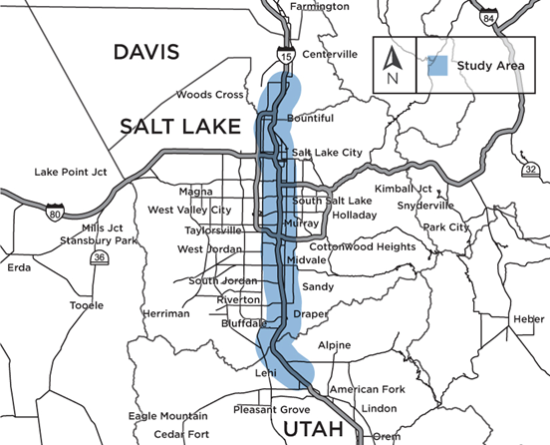  
FIGURE 7 Wasatch Front Central Corridor Study Area  
  
  
 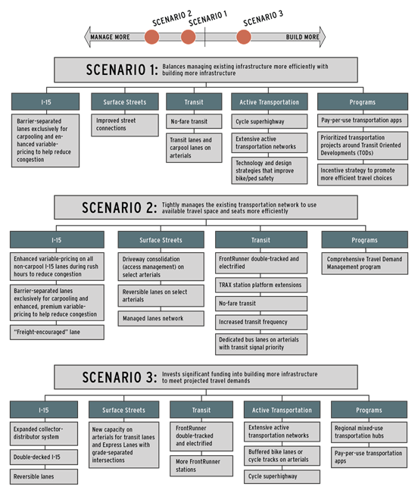  
  
  
FIGURE 8 Infrastructure Scenarios in the Wasatch Front Central Corridor Study  
  
   
  
 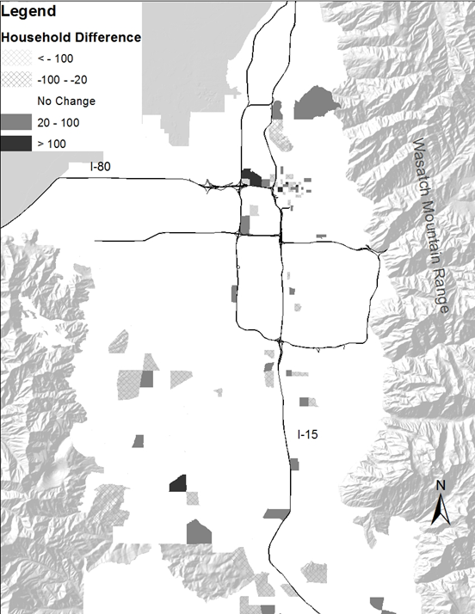  
FIGURE 9 Shift in Household Location in Scenario 1   
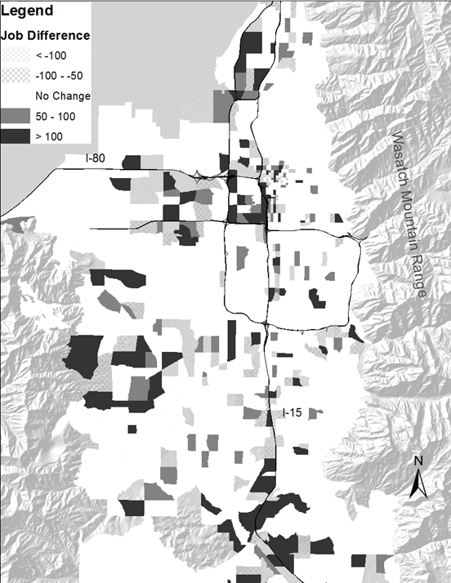  
   
FIGURE 10 Shift in Employment Location in Scenario 1  
 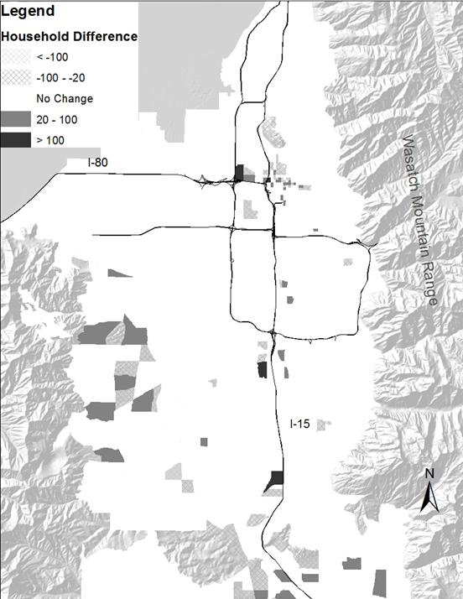  
  
FIGURE 11 Shift in Household Location in Scenario 2  
 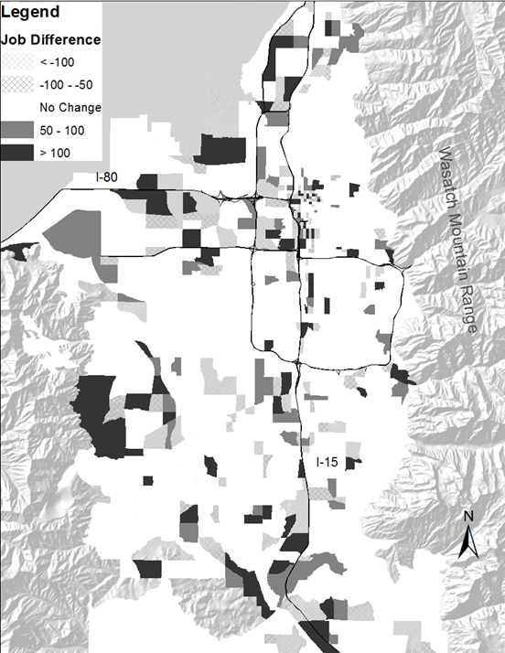  
  
   
FIGURE 12 Shift in Employment Location in Scenario 2  
  
   
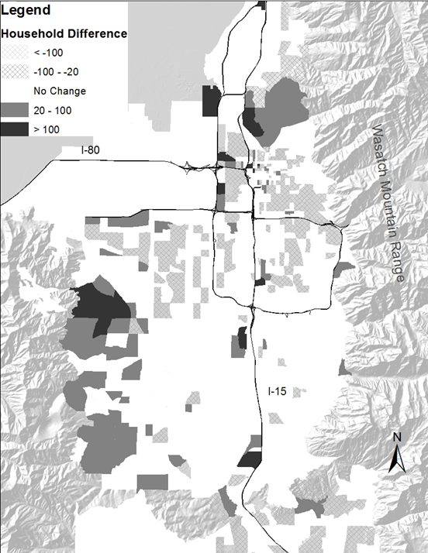  
   
FIGURE 13 Shift in Household Location in Scenario 3  
   
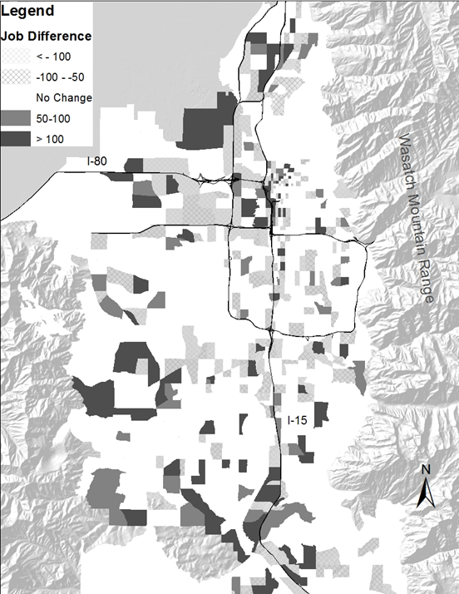  
   
FIGURE 14 Shift in Employment Location in Scenario 3

## West Corridor Study

We evaluated a new limited access, divided highway in Davis County, locally called the West Davis Connector. The analysis was fairly straight forward. The integrated land use and transportation forecasting model, REMM, was asked to model the county, through 2050 (from a 2011 base year), with and without the Davis Connector. This was done to determine land use shifts that would occur and the transportation implications of this land use shift that resulted from the capital improvement. Figure 15 shows the shift in household location that resulted from the Davis Connector. Figure 16 shows the change in employment location from the Davis Connector. Note that the land use shifts were impacted by the local zoning constraint which called for single family residential development in the vicinity of the Davis Connector. REMM was not permitted to allocate non-permitted land uses in these simulations. A facility like the Davis Connector would have a much stronger pull on non-residential uses as they are more sensitive to transport accessibility.

Not surprisingly, land use shifted at interchange locations along the alignment of the new facility. Perhaps more intriguing is the substantial shift in households that occurred north of the termination of the facility. The increased access provided to previously underserved land stimulated significant growth in this area (see Figures 15 and 16).

Agency partners were in agreement that, given the zoning constraint, this represented a realistic or at least feasible land use shift given the infrastructure scenario being modeled. REMM was deemed successful in this application and was used to help decision makers select this capital improvement for development.   
   
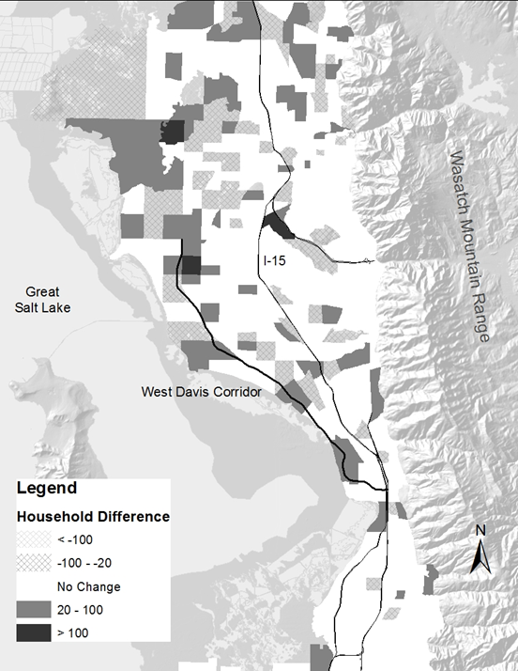  
   
FIGURE 15 Household Location Shift from the Davis Connector  
  
 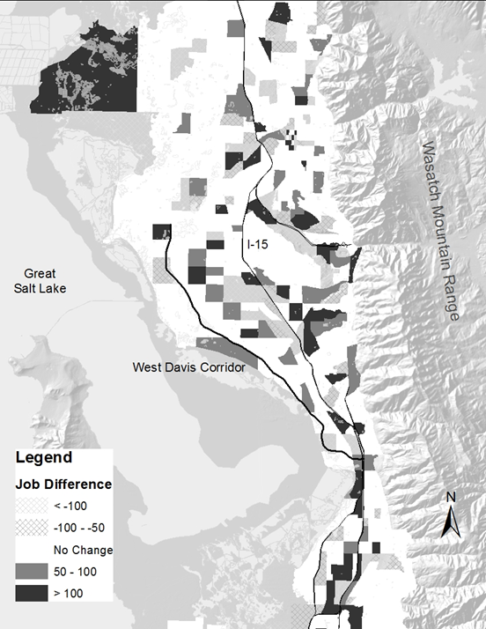  
  
FIGURE 16 Employment Location Shift from the Davis Connector

## Regional Transportation Plan Scenario Selection and Phasing

REMM was used to support the development of 2019-2050 regional transportation plan for WFRC. Integrated REMM with travel models were run for scenario selection, phasing, and final social economic forecasting. Land use changes between scenarios, including Wasatch Choice centers, were coded in to the land use policy change table. The output building table was used to calculate the performance measures of developed land for scenario/phasing comparison. The output socioeconomic data was used as the input of the travel demand model for transportation decision support.

## Region Wide Model for the GPI.

A separate model was built for the GPI to forecast county-level households and employments. The county-level parcels and buildings data was adjusted to be comparable between the counties. Regional price models and location choice models were all re-estimated. county-level constants were added to the location choice models to calibrate the models to follow the recent growth trend from 2011 to 2015.

# Planned Future Enhancements to REMM

1. Summer 2019 Peer Review of REMM

2. Visualization Tools

3. Update General Plan Layer

4. Pipeline Project Input Data Process

5. Rewrite REMM Developer Module (Incremental Development)

6. Cloud Test of REMM

7. Re-estimate or Review All of the Model Parameters

8. Add Brigham City

9. GPI version – region model Update

# References

[http://www.urbansim.com](http://www.urbansim.com/)

Clay, Michael J. (submitted April 2018, under review) Infrastructure Alternatives Analysis with an Integrated Land Use and Transportation Forecasting Model. Journal of Urban, Planning and Transportation Research.

Appendix

All Variables

| Zone Variables | Building Variables | Node Variables |
| --- | --- | --- |
| parcel_count | building_type_id | train_stn_1500 |
| jobs_2_within_10_min | non_residential_sqft | train_stn_500 |
| pop_density | note | jobs_7_1000 |
| population_within_10_min | parcel_id | jobs_7_500 |
| tdm_county_id | residential_units | jobs_ind_500 |
| ave_age_of_head | stories | jobs_ind_1000 |
| population_within_40_min | unit_price_non_residential | jobs_ind_1500 |
| jobs_within_30_min_transit | year_built | jobs_ofc_500 |
| jobs_7_within_10_min | res_price_per_sqft | jobs_ofc_1000 |
| ave_hhchildren_zn | residential_price | jobs_ofc_1500 |
| jobs_1_within_10_min | non_residential_price | bus_stop_1500 |
| logsum_jobs10 | job_spaces | bus_stop_200 |
| nonres_median_price | building_sqft | ave_sqft_per_unit |
| population_within_40_min_transit | distmed_32 | ave_sqft_per_unit_500 |
| res_units_within_30_min | distmed_33 | ave_lot_size_per_unit |
| res_median_price | distmed_30 | ave_lot_size_per_unit_500 |
| ind_median_price | distmed_31 | ave_income_1500 |
| population_within_20_min | distmed_36 | ave_income_1000 |
| total_jobs | distmed_37 | ave_income_500 |
| ave_hhsize_zn | distmed_34 | sfdu_1500 |
| jobs_9 | distmed_35 | sfdu_1000 |
| jobs_8 | distmed_38 | sfdu_500 |
| jobs_5_within_10_min | distmed_39 | mfdu_1500 |
| jobs_9_within_10_min | is_office | mfdu_500 |
| jobs_3 | bus_stop_dist | mfdu_1000 |
| jobs_2 | elevation | high_income_1500 |
| jobs_1 | distmed_med_inc | high_income_1000 |
| sum_land_value | distmed_21 | low_income_1500 |
| ret_median_price | distmed_20 | low_income_1000 |
| jobs_6 | distmed_23 | low_income_500 |
| jobs_5 | distmed_22 | jobs_1500 |
| jobs_4 | distmed_25 | jobs_500 |
| population_within_30_min | distmed_24 | jobs_200 |
| jobs_10 | distmed_27 | jobs_1_1500 |
| jobs_6_within_10_min | distmed_26 | jobs_1_500 |
| jobs_8_within_10_min | distmed_29 | jobs_2_1500 |
| jobs_10_within_10_min | distmed_28 | jobs_2_1000 |
| total_households | distlrg_id | jobs_2_500 |
| jobs_within_15_min | trail_dist | jobs_3_1500 |
| ave_nonres_price_zn | raildepot_dist | jobs_4_1500 |
| seg_col | lot_size_per_unit | jobs_4_500 |
| logsum_jobs2 | distmed_14 | jobs_5_1500 |
| logsum_jobs3 | distmed_15 | jobs_5_500 |
| logsum_jobs1 | distmed_16 | jobs_6_1500 |
| logsum_jobs6 | distmed_17 | jobs_6_500 |
| median_income | distmed_10 | jobs_7_1500 |
| logsum_jobs4 | distmed_11 | jobs_8_1500 |
| logsum_jobs5 | distmed_12 | jobs_9_1500 |
| land_value_per_acre | distmed_13 | jobs_9_500 |
| logsum_jobs8 | utmyi | jobs_10_1500 |
| logsum_jobs9 | distmed_18 | jobs_10_500 |
| hh_choice_control | distmed_19 | jobs_3_1000 |
| logsum_hhinc3 | distmed_2 | jobs_5_1000 |
| logsum_hhinc2 | distmed_3 | jobs_6_1000 |
| logsum_hhinc1 | distmed_1 | jobs_8_1000 |
| jobs_within_20_min | distmed_6 | industrial_sqft_1000 |
| jobs_within_40_min_transit | distmed_7 | workers_1500 |
| logsum_jobs7 | distmed_4 | fwy_exit_1500 |
| logsum_hhinc4 | distmed_5 | fwy_exit_1000 |
| ave_hhpropwkrs_zn | airport_distance | train_stn_1000 |
| jobs_4_within_10_min | distmed_8 | rail_depot_1000 |
| population_within_15_min | distmed_9 | ave_children_500 |
| logsumjobs | is_sf | sum_nonresidential_units_500 |
| logsumpopulation | improvement_value | stream_200 |
| population | utmxi | trail_200 |
| ofc_median_price | rail_stn_dist | trail_500 |
| jobs_within_20_min_transit | parcel_acres | trail_1000 |
| jobs_3_within_10_min | stream_dist |  |
| jobs_within_30_min | is_govt |  |
| commute_time | zone_id |  |
| commute_time_20 | volume_two_way_nofwy |  |
| population_within_20_min_transit | is_retail |  |
| jobs_7 | airport |  |
| res_units_within_20_min | general_type |  |
| ave_hhincome_zn | fwy_exit_dist |  |
| ave_res_price_zn | total_job_spaces |  |
| building_age_zn | is_mf |  |
| hh_target_2015 | real_far |  |
| population_within_30_min_transit | residential_sqft |  |
| jobs_within_10_min | max_far |  |
| ave_hhcars_zn | is_mixeduse |  |
|  | avg_building_age |  |
|  | distmed_id |  |
|  | residential_sales_price_sqft |  |
|  | sqft_per_job |  |
|  | zone_1212 |  |
|  | volume_two_way |  |
|  | sqft_per_unit |  |
|  | university_dist |  |
|  | parcel_volume |  |
|  | vacant_residential_units |  |
|  | county_id |  |
|  | distsml_id |  |
|  | is_industrial |  |
|  | vacant_job_spaces |  |
|  | bus_rte_dist |  |
|  | building_age |  |
|  | distlrg_med_inc |  |
|  | distmed_41 |  |
|  | distmed_40 |  |
|  | land_value |  |
|  | node_id |  |
|  | unit_price_residential |  |
|  | distsml_med_inc |  |
|  | fwy_exit_dist_tdm_output |  |
|  | rail_depot |  |
|  | is_other |  |